NATIONAL ASSEMBLY
36/1/4/1(201900005)

FOR WRITTEN REPLY

QUESTION 118

DATEOFPUBL!CATlONlN!NTERNALOUESTlONPAPER:7FEBRUARY2019 flNTERNALOUESTONPAPERNO1-2019)
118. Ms V van Dyk (DA) to ask the Minister of Police:

- What number of (i) cases relating to incidents of illegal mining have been investigated by the SA Police Service since 1 January 2014 and (ii) the specified cases resulted in a conviction and (b) on what statutory grounds was each conviction made?
NW123E
REPLY:

Directorate for Priority Crime Investigation

(a)(i) From 1 January 2014 to 31 December 2018, the Directorate for Priority Crime Investigation (DPCI) investigated a total of 364 incidents, regarding illegal mining.
(a)(ii) A total of 186 convictions were obtained, from 1 Jan“uary 2014 to 31 December 2018.

Division: Detective Service, South African Police Service

(a)(i) The number of cases, relating to incidents of illegal mining, investigated by the Division: Detective Service, South African Police Service (SAPS), from 1 January 2014 to date, is reflected in the table below:

Province | Year  2014 2015 2016 2017 2018 2019
Eastern Cape | 0 | 0 | 0 | 0 | 0 | 0
Free State | 321 | 180 | 201 | 256 | 299 | 32
Gauteng | 0 | 0 | 0 | 0 | 0 | 0
KwaZulu-Natal | 1 | 3 | 1 | 1 | 4 | 0
Limpopo | 0 | 0 | 0 | 37 | 27 | 1
Mpumalanga | 46 | 53 | 59 | 114 | 253 | 29
North West | 2 | 0 | 2 | 5 | 2 | 0
Northern Cape | 1 | 1 | 3 | 9 | 30 | 1
Western Cape | 1 | 1 | 3 | 9 | 30 | 1
Total | 372 | 238 | 269 | 431 | 645 | 64

2

(a)(ii) The number of cases, which resulted in a conviction, is as follows:
Year
Province
 | 2014 | 2015 |  |  | 2018 | 2019
Eastern Cape | 0 | 0 | 0 | 0 | 0 | 0
Free State | 284 | 120 | 132 | 171 | 246 | 7
Gauteng | 0 | 0 | 0 | 0 | 0 | 0
KwaZulu-Natal | 0 | 0 | 0 | 0 | 0 | 0
Limpopo | 0 | 0 | 0 | 10 | 2 | 0
Mpumalanga | 18 | 24 | 34 | 42 | 81 | 0
North West | 0 | 0 | 0 | 1 | 0 | 0
Northern Cape | 0 | 0 | 3 | 1 | 0 | 0
Western Cape | 0 | 0 | 0 | 0 | 0 | 0
Total | 302 | 144 | 169 | 225 | 329 | 7

2016 2017

- The statutory grounds for the convictions, were as follows:
---› Trespassing, in terms of the Trespass Act, 1959 (Act No. 6 of 1959).
---› Unlawful possession of unwrought precious metal, in terms of the Precious Metals Act, 2005 (Act No. 37 of 2005).
Unlawful dealing in unwrought precious metal, in terms of the Precious Metals Act, 2005 (Act No. 37 of 2005).
Unlawful possession of unpolished/uncut diamonds, in terms of the Diamonds Act, 1986 (Act No. 56 of 1986).
Unlawful dealing in unpolished/uncut diamonds in terms of the Diamonds Act, 1986 (Act No. 56 of 1986).
Racketeering, in terms of the Prevention of Organised Crime Act (Act No. 121 of 1998).
Money laundering, in terms of the Prevention of Organised Crime Act, 1998 (Act No. 121 of 1998).
Illegal immigration, in terms of the Immigration Act, 2002 (Act No. 13 of 2002).
Illegal prospecting, in terms of the Mining Rights Act, 1967 (Act No. 20 of 1967).
Failing to lodge prospecting rights, in terms of the Mineral and Petroleum Resources Development Act, 2002 (Act No. 28 of 2002).
Common law offences, such as theft, fraud, housebreaking and robbery.

Reply to question 118 recommended

LE (SOEG)

GENERAL ION OUTH AFRICAN POLICE SERVICE

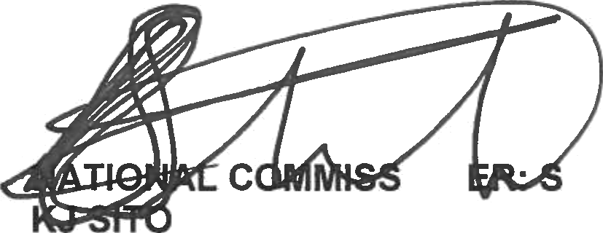
Reply to question 118 approved/not approved

MINISTER OF POLICE BH CELE, MP

Date:

