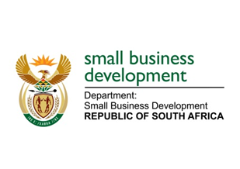
NATIONAL ASSEMBLY

QUESTION FOR WRITTEN REPLY

“1177. Mr N E Hinana (DA) to ask the Minister of Small Business Development:

Whether her department incurred any costs related to the (a) inauguration of the President of the Republic, Mr M C Ramaphosa, held in Pretoria on 25 May 2019 and (b) State of the Nation Address held in Cape Town on 20 June 2019; if so, in each case, (i) what costs were incurred and (ii) for what reason?”
NW2338E
REPLY:
- The Department of Small Business and Development (DSBD) did not incur any costs in relation to the inauguration of the President of the Republic held on 25 May 2019.
- In terms of the State of Nation Address held on 20 June 2019, only travel and accommodation costs were incurred by the DSBD as follows:

Attendee | (b)(i) Travel and accommodation costs | (b)(ii) Reason
Minister of Small Business Development  - Flight, R10 800.17  (18-21 June 2019)  - Accommodation, 9 356.72  (18-21 June 2019) | R 20 156.89 | Attending Special Cabinet Meeting, Presidential Youth Dialogue, meeting with Vodacom and attending the State of the Nation Address
Deputy Minister of Small Business Development  - Flight, R13 409.78  (3 way flights) | R13 409.78 | Attending the State of the Nation Address
Guest of the Minister of Small Business Development  - Guest flight, R8 216.17  (20-21 June 2019)  - Guest shuttle in PTA, R1731.13 (20-21 June 2019) | R 9 947.30 | Accompanying the Minister to the State of the Nation Address
TOTAL | R43 513 97

