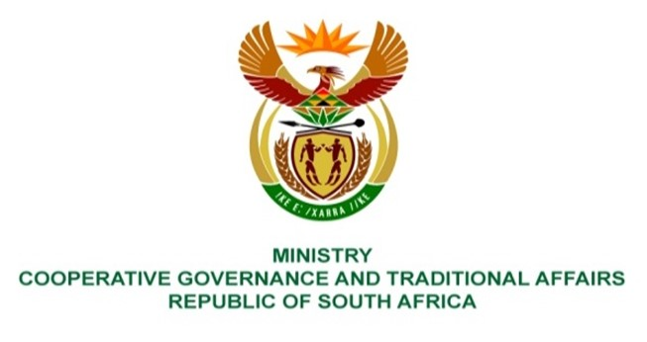

NATIONAL ASSEMBLY
QUESTION FOR WRITTEN REPLY

QUESTION NUMBER 1174
DATE OF PUBLICATION: 31 MARCH 2023

1174. Ms L H Arries (EFF) to ask the Minister of Cooperative Governance and Traditional Affairs:
(a) What is the total number of municipalities that have been issued with Section 106 notices since 1 January 2019, (b) who is the investigative service provider investigating the municipalities and (c) what is the total cost paid to the service provider for investigating the municipalities regarding the specified section? NW1315E
REPLY:

The response below was provided by the provincial departments of Cooperative Governance and Traditional Affairs from the various provinces. Out of the 9 provinces, 7 provinces have submitted responses. We are still awaiting responses from KwaZulu Natal and North West provinces. A total of 35 municipalities have been issued with Section 106 notices since 1 January 2019. The details are provided below:
Province | Total no of municipalities. | Service provider appointed to investigate. | Total cost paid to service provider.
Eastern Cape | 15 | 15 Section 106 notices issued since 2019. Out of the 15, 14 of the investigations were conducted internally. Service provider appointed was Integrated Forensic Accounting Firm (Buffalo City Metro). | R750 000.00
Free State | 5 | 5 Section 106 notices issued. All investigations were done internally, as such no service provider was appointed. | N/A
Gauteng | 2 | 2 Section 106 notices issued since 2019. Service provider appointed for both was Adv. William Mokhare SC, assisted by two Junior Advocates.  (i) Sedibeng DM; and  (ii) Rand West LM. | R 4 869 362.06.
KwaZulu Natal | Still awaiting  response from the province. | N/A | N/A
Limpopo | 6 | 6 Section 106 notices issued since 2019. All investigations were done internally, as such no service provider was appointed. | N/A
Mpumalanga | 7 | 7 Section 106 notices issued since 2019, conducted by service providers listed below:  (i) AGNOWIZ (Dr JS Moroka LM);  (ii) TMN Kgomo & Associates Inc ( Pixley Ka Isaka Seme LM);  (iii) Motlatsiseleke Inc (Govan Mbeki LM);  (iv) SAMBA Solutions (Dipaleseng LM);  (v) Motlatsiseleke Inc (Nkomazi LM);  (vi) Analytical Forensic Investigation Services (Emalahleni LM); and  (vii) RCA & Company (Bushbuckridge LM) | (i) AGNOWIZ (R456 205.00)  (ii) TMN Kgomo & Associates Inc (R495 650.00)  (iii)Motlatsiseleke Inc (R498 950.00)  (iv) SAMBA Solutions (R953 748.00)  (v) Motlatsiseleke Inc (R498 950.00)  (vi) Analytical Forensic Investigation Services (R787 228.00)  (vii) RCA & Company (R885 753.00).
North West | Still awaiting  response from the province. | N/A | N/A
Northern Cape | No Section 106 notices issued since 2019. | N/A | N/A
Western Cape | 5 | 6 Section 106 notices issued since 2019, conducted by service providers (persons designated) listed below:  (i) Ms Annelita Mentoor & Mr Anthony Botha; and  Adv Etienne Vermaak, Ms Annelita Mentoor & Mr Pieter Van Hansen (George LM);  (ii) Ms Carmelita Beerwinkel & Mr Marius Pretorius (Central Karoo DM);  (iii) Ms Deirdre Viljoen & Mr Marc Diergaardt (Kannaland LM);  (iv) Adv Charl Strydom & Ms Estelle Mynhardt (Matzikama LM); and  (v) Mr Charl Gerber & Ms Nimerah Singh (Beaufort West LM) | (i) Ms Annelita Mentoor & Mr Anthony Botha (R1 479 356.20); and  Adv Etienne Vermaak, Ms Annelita Mentoor & Mr Pieter Van Hansen (R1 833 050.00).  (ii) Ms Carmelita Beerwinkel & Mr Marius Pretorius (R908 050.00);  (iii) Ms Deirdre Viljoen & Mr Marc Diergaardt (R714 999.00);  (iv) Adv Charl Strydom & Ms Estelle Mynhardt (R1 203 585.00); and  (v) Mr Charl Gerber & Ms Nimerah Singh (R1 110 500.00)
End.

