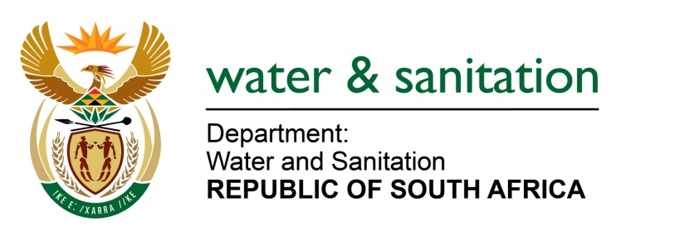

NATIONAL ASSEMBLY

FOR WRITTEN REPLY

QUESTION NO 1173

DATE OF PUBLICATION IN INTERNAL QUESTION PAPER: 12 MAY 2017
(INTERNAL QUESTION PAPER NO. 16)

1173. Mr S Esau (DA) to ask the Minister of Water and Sanitation:

With regard to her reply to question 208 on 24 February 2017, what was the outcome of the joint assessment undertaken by her department and the Ekurhuleni Metropolitan Municipality? NW1313E
---00O00---
REPLY:
The joint assessment initiated by both Ekurhuleni and Rand Water revealed that Rand Water did not disturb the storm water infrastructure whilst laying the new pipeline. It should be noted that the joint assessment undertaken did not include my Department but was undertaken by Rand Water and the Ekurhuleni Metropolitan Municipality.
Furthermore, requesting the Honourable Member to refer the question to the Minister of Cooperative Governance and Traditional Affairs, who is in a better position to respond to issues relating to the plans going forward by the Ekurhuleni Metropolitan Municipality in Gauteng.
---00O00---

