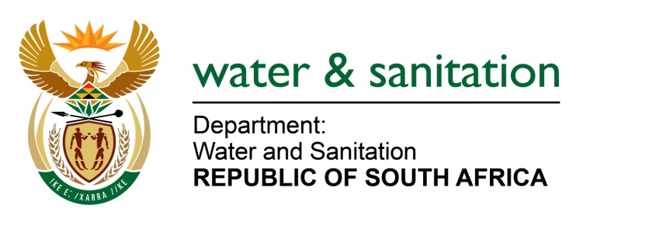

NATIONAL ASSEMBLY

FOR WRITTEN REPLY

QUESTION NO 1172

DATE OF PUBLICATION IN INTERNAL QUESTION PAPER: 12 MAY 2017
(INTERNAL QUESTION PAPER NO. 16)

1172. Mr M Waters (DA) to ask the Minister of Water and Sanitation:

Whether, with reference to the declaration of Eastleigh as a disaster area by the Premier of Gauteng, her department has applied for disaster funding in order to repair the Eastleigh solute channel damaged by flooding on 9 November 2016 in the Ekurhuleni Metropolitan Municipality in Gauteng; if not, why not; if so, (a) what is the total amount that has been applied for, (b) on what date was the application submitted and (c) what is the outcome of the application? NW1312E
---00O00---
REPLY:
No, my Department did not apply for disaster funding in order to repair the Eastleigh solute channel damaged by flooding on 09 November 2016 in the Ekurhuleni Metropolitan Municipality (EMM).
Requesting the Honourable Member to refer the question to the Minister of Cooperative Governance and Traditional Affairs, who is in a better position to respond to issues relating to the application for disaster funding in order to repair the Eastleigh solute channel damaged by flooding on 9 November 2016 in the EMM in Gauteng.
---00O00---

