National Assembly
Question 1171

Mr T Mogale (EFF) to ask the Minister of Transport:
Whether SANRAL has any plans to tar the road connecting Verkeerdevlei with Thaba Nchu as it provides the shortest access to Thaba Nchu from the N1; if not, why not; if so, what are the relevant details? NW1312E

- REPLY
The road connecting N1 Verkeerdevlei with Thaba Nchu is not a SANRAL road but a Free State Provincial Road. It is also not part of the identified Strategic and Primary Network still to be transferred to SANRAL by the Free State Province.
As this is not a SANRAL road, SANRAL has neither the mandate nor plans to tar the road in question.
However the details of the plans by the Province will be sourced and submitted to Parliament.
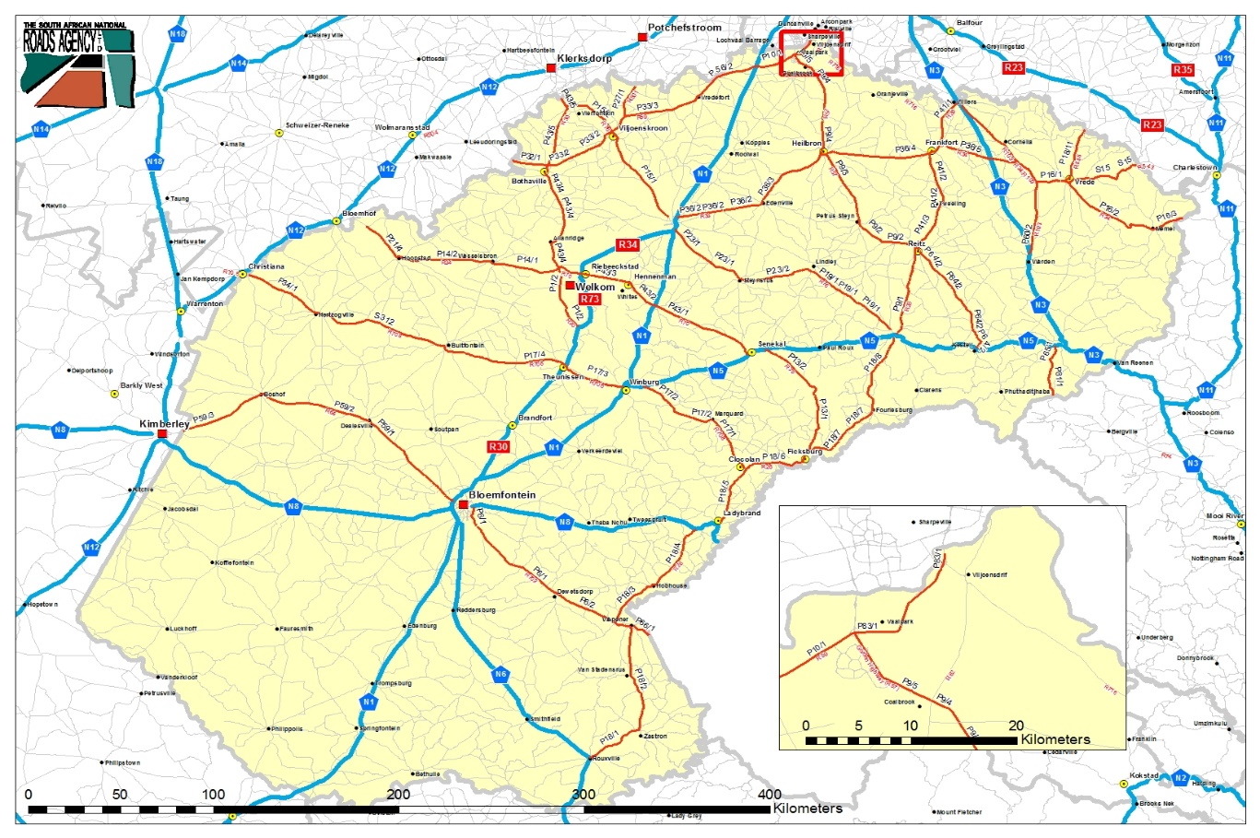
The route between Thaba Nchu and Excelsior consists of various sections of roads as per the Free State Department of Police, Roads and Transport asset register. The Department has come a long way in upgrading certain section from gravel to block pave or Cape Seal over the past number of years. These upgrades are done in line with the Department's plans to provide a suitable bus route to service the Thaba Nchu area. It therefore provides a ring road and there is no plan for providing an upgraded road to Excelsior as road traffic counts do not seem to justify an upgrade at this time.
Traffic counts may be extrapolated to confirm the number of vehicles traveling between Thaba Nchu and Excelsior and this might provide justifiable ground for such an upgrade.

