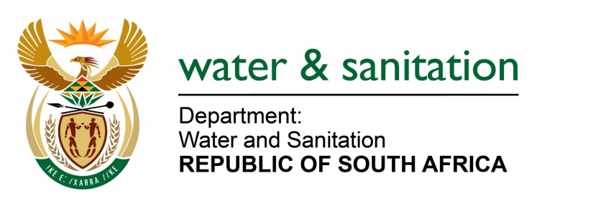

NATIONAL ASSEMBLY

FOR WRITTEN REPLY

QUESTION NO 1171

DATE OF PUBLICATION IN INTERNAL QUESTION PAPER: 12 MAY 2017
(INTERNAL QUESTION PAPER NO. 16)

1171. Mr M Waters (DA) to ask the Minister of Water and Sanitation:

(a) When last was the Eastleigh solute channel in the Ekurhuleni Metropolitan Municipality in Gauteng, which was damaged by flooding on 9 November 2016, maintained and (b) what amount was paid towards the maintenance? NW1311E
---00O00---
REPLY:
Requesting the Honourable Member to refer the question to the Minister of Cooperative Governance and Traditional Affairs, who is in a better position to respond to issues relating to the maintenance and cost of maintenance of the Eastleigh solute channel in the Ekurhuleni Metropolitan Municipality in Gauteng
---00O00---

