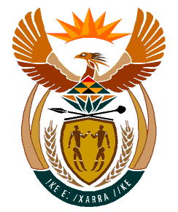

MINISTRY
HUMAN SETTLEMENTS
REPUBLIC OF SOUTH AFRICA

Private Bag X645, Pretoria, 0001. Tel: (012) 421 1309, Fax: (012) 341 8513
Private Bag X9029, Cape Town, 8000. Tel (021) 466 7603, Fax: (021) 466 3610

NATIONAL ASSEMBLY

QUESTION FOR WRITTEN REPLY

QUESTION NUMBER: 1170

DATE OF PUBLICATION: 31 MARCH 2023

1170. Mrs SM Mokgotho (EFF) to ask the Minister of Human Settlements:
On what date will the (a) Black Joint and (b) GG Camp informal settlements outside Oudtshoorn be (i) formalised and (ii) electrified as they have been requesting the specified for the past 20 years?
NW1311E

REPLY

(a)(b)(i) The Western Cape Provincial Department advised the National Department of Human Settlements that Oudtshoorn Municipality has recently appointed an implementing agent that will be responsible for the upgrading of Black Joint and GG Camp informal settlements. The Municipality is finalising land ownership issues which have in the past stalled the upgrading of the two informal settlements up until now. In addition, the municipality will also complete a Project Feasibility Report for approval to the Provincial Department of Infrastructure. The project is expected to be implemented in the 2024/25 financial year.

(ii) Once the Municipality has resolved all the outstanding land issues related to the project and submitted its Project Feasibility Report, the upgrading of Black Joint and GG Camp is envisaged to commence in the 2024/25 financial year. This will allow the Municipality also to apply for the necessary funding to provide electricity and other requisite infrastructure to the two informal settlements.

