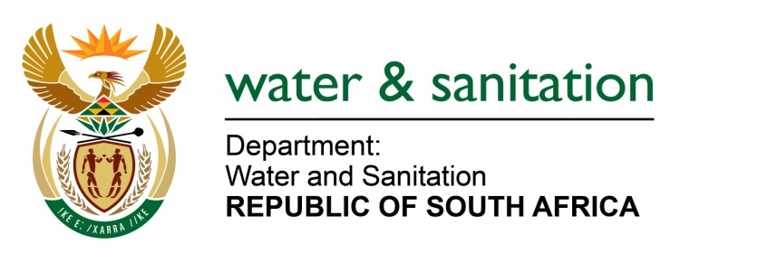

NATIONAL ASSEMBLY

FOR WRITTEN REPLY

QUESTION NO 1170

DATE OF PUBLICATION IN INTERNAL QUESTION PAPER: 12 MAY 2017
(INTERNAL QUESTION PAPER NO. 16)

1170. Mr M Waters (DA) to ask the Minister of Water and Sanitation:

(a) By what date will her department repair the Eastleigh solute channel in the Ekurhuleni Metropolitan Municipality in Gauteng, which was damaged by flooding on 9 November 2016, (b) what is the estimated cost of repair and (c) by what date is the repair work expected to be completed? NW1310E

---00O00---
REPLY:

My Department is not repairing the Eastleigh solute channel damaged by flooding on the 09 November 2016 in the Ekurhuleni Metropolitan Municipality (EMM).
Requesting the Honourable Member to refer the question to the Minister of Cooperative Governance and Traditional Affairs, who is in a better position to respond to issues relating to the repairing of the Eastleigh solute channel in the EMM in Gauteng.
---00O00---

