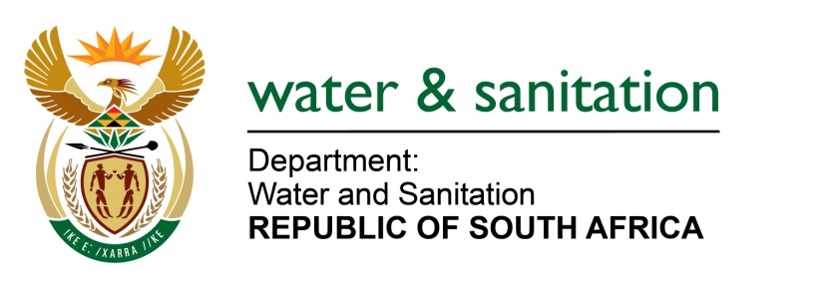

NATIONAL ASSEMBLY

FOR WRITTEN REPLY

QUESTION NO 1167

DATE OF PUBLICATION IN INTERNAL QUESTION PAPER: 31 MARCH 2023
(INTERNAL QUESTION PAPER NO. 12)

1167. Mr K Ceza (EFF) to ask the Minister of Water and Sanitation:
Whether he received any complaints regarding potable water quality in the (a) Steve Tshwete Local Municipality and (b) Emalahleni Local Municipality as a result of coal mining in the surrounding area; if not, what is the position in this regard; if so, what (i) steps has his department taken to solve the water quality problem and (ii) are the further relevant details? NW1308E
---00O00---

MINISTER OF WATER AND SANITATION

- There are no recent complaints regarding potable water quality that were received by the Department of Water and Sanitation from the Steve Tshwete Local Municipality. All previously reported cases were closed after the municipality implemented corrective measures to address the reported complaints.

- The Department received complaints regarding poor water quality in Emalahleni Local Municipality and has initiated an investigation. The findings of the investigation were that some of the mines were discharging non-compliant water into the water streams or systems. The Department issued notices of intention to issue directives on 17th February 2023, through the provisions of Section 19 of National Water Act to the mines. These mining companies were given until the end of April 2023 to implement corrective measures. Failure to comply and submit these to the Department will result in the Department issuing a Directive.

- The Department has assisted the Steve Tshwete Local Municipality with funding under Regional Bulk Infrastructure Grant (RBIG) for the refurbishment and upgrading of the Vaalbank Water Treatment Works to improve process performance and ensure acceptable drinking water quality. The construction of the 20Ml/d reverse osmosis plant and a filter system to reduce turbidity and sulphate concentration is underway. The project is due to be completed in November 2023.

Furthermore, it should be noted that the Department is currently conducting a feasibility study to investigate the provision of bulk water supply for the Emalahleni Local Municipality that is aimed at identifying and developing alternative solutions to address the bulk water supply infrastructure deficiencies. Construction is planned to commence in 2024.

- In addition, the Department also rendered financial support for the two municipalities as indicated in the table below:

 | 2022/23 |  | 2023/24
 | RBIG | WSIG | RBIG | WSIG
Steve Tshwete LM | R145 mil | R35 mil | R100 mil | R12 mil
Emalahleni LM | - | R15 mil | R1.5 mil | R15 mil

---00O00---

