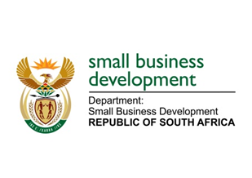
NATIONAL ASSEMBLY
QUESTION FOR WRITTEN REPLY
DUE TO PARLIAMENT ON FRIDAY, 26 JUNE 2020

1162. Mr H C C Krüger (DA) to ask the Minister of Small Business Development:

Whether her department has a strategy to assist existing small, micro and medium enterprises to start conducting business again after the devastating effects that Covid–19 had on their businesses; if not, what is the position in this regard; if so, (a) what are the relevant details and (b) on what date is it envisaged that the department will start rolling out the assistance? NW1467E

REPLY:
To assist existing SMMEs to start conducting businesses again after the effects of Covid-19, the Department of Small Business Development has initiated various programmes to support both formal and informal businesses. The informal and micro-business support schemes include:
- The Spaza Support – this scheme is not only meant to su
- Small Scale Bakeries and Confectioneries Business Support Scheme;
- Small Scale and Micro Clothing, Textile and Leather Business Support Scheme; and
- Automotive Aftermarkets Support Scheme.

More dedicated interventions such as those for butcheries, informal restaurants, personal care support are being finalised to support the micro and informal businesses to ensure the most vulnerable sector, which employs the largest number of people is adequately supported. These schemes fit in well with the Cabinet approved Township and Rural Entrepreneurship Programme that the DSBD is expected to implement during this current financial year.

In addition, the Department of Small Business Development is finalising other interventions to support formal SMEs when they return back to business activities during and post-Covid-19 pandemic. These interventions include the Business Viability scheme, which is targeting businesses through the economic recovery phase as we will be ensuring that SMMEs are ready to adjust to the new ways of doing business and ensuring that their business processes are adjusted to suit the new ways of doing business. Another intervention is the small scale manufacturing scheme to support and bolster local manufacturing as part of the department’s localization programme.

Public announcements are made as and when a support programme is ready to be rolled out. The four interventions specified in the first paragraph above, were all in place by the 24 May 2020.

