

**MINISTRY**

**STATE SECURITY**

**REPUBLIC OF SOUTH AFRICA**

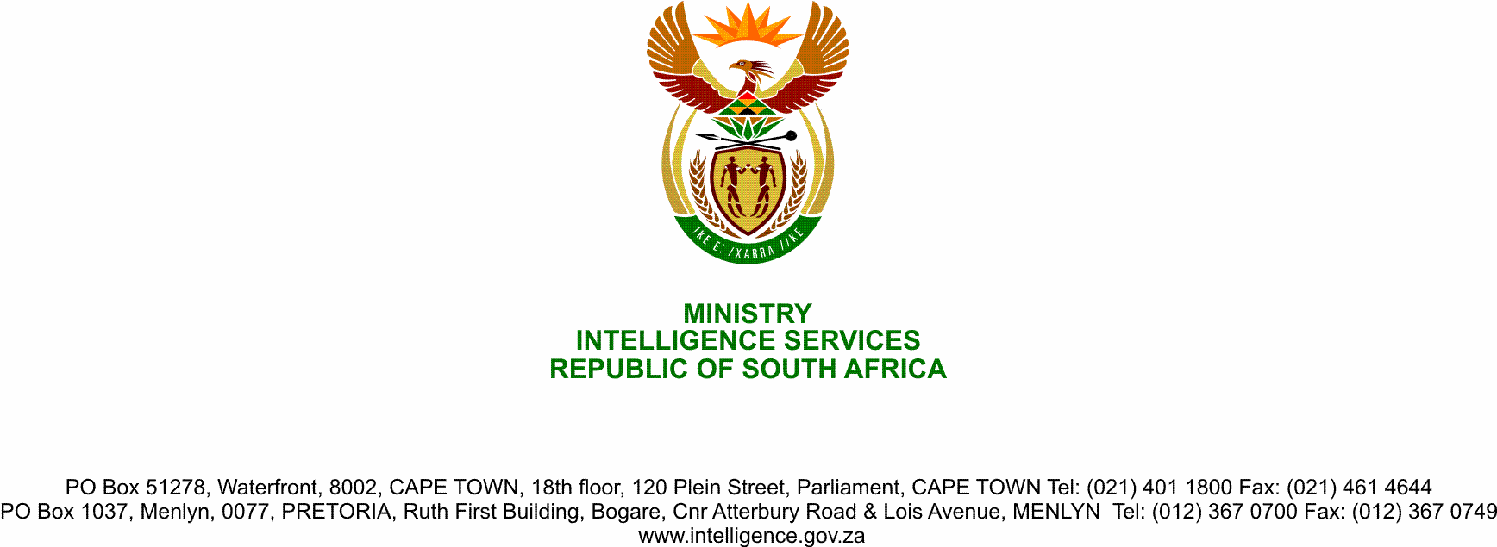

**NATIONAL ASSEMBLY**

**QUESTION FOR WRITTEN REPLY**

**QUESTION NO.: 1159.**

**Dr P J Groenewald (FF Plus) to ask the Minister of State Security:**

(1) With reference to her reply to question 934 on 8 June 2020, what was the amount of each transaction with each company mentioned in her reply;

(2) whether her department purchased any goods and/or services below the amount of R500 000 connected to the Covid-19 pandemic; if not, what is the position in this regard; if so, what (a) is the name of each company from which the specified goods and/or services were purchased, (b) is the amount of each transaction and (c) was the service and/or product that each company rendered;

(3) whether there was any deviation from the standard supply chain management procedures in the transactions; if so, (a) why and (b) what are the further relevant details in each case;

(4) what were the reasons that the goods and/or services were purchased from the specified companies;

(5) whether she will make a statement on the matter?

NW1462E

**REPLY**

1. 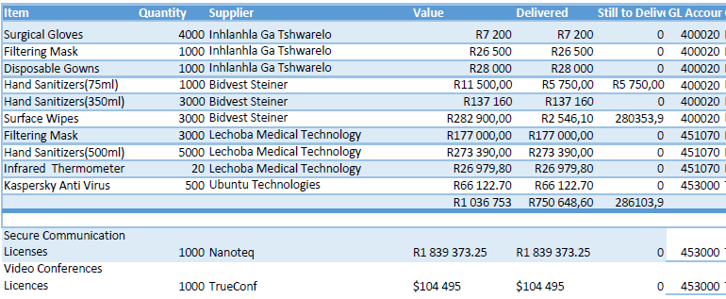In the response to Parliamentary Question 934 on 8 June 2020, items, suppliers and amounts were tabulated and repeated below:

Hence to answer Parliamentary Question 1159 that asks about specifically companies and total amounts, transactions with Inhlanhla Ga Tshwarelo amounted to R61 700.00, those with Bidvest Steiner to R431 560.00, those with Lechoba Medical Technology to R477 369.80, and those with Ubuntu Technologies to R66 122.70.

(2) Regarding the purchasing of goods and/or services below the amount of R500 000 connected to the Covid-19 pandemic;

(a) goods and/or services were purchased from Ga Tshwarelo, Bidvest Steiner, Lechoba Medical Technology, and Ubuntu Technologies as indicated above.

(b) the transaction amounts are those mentioned in answer (1).

(c) Ga Tshwarelo supplied masks, gloves and disposable masks; Bidvest Steiner provided sanitisers and surface wipes; Lechoba Medical Technology supplied filtering masks, sanitisers and infrared thermometers, and Ubuntu Technologies supplied anti-virus software and licences to ensure secure, remote communication.

(3) SSA followed a deviation process

(a) to provide a Secure Video Conferencing Solution for Government on an urgent basis to allow work to continue while minimising the health risks posed by infectious Covid-19.

(b) The financial details are reflected in the table above.

(4) Goods and/or services were purchased/acquired adhering to National Treasury instructions 2020/2021 in relation to the Emergency Procedures in response to the National State of Disaster. Companies were selected that met National Treasury’s requirements and/or were among those identified and proposed by it.

The reason for choosing the said Information Technology supplier is that the Agency already had contracts with the two companies Nanoteq and TrueConf that provided infrastructure to the SSA on secure communications and video conferencing solutions respectively. Consequently, the SSA approached the two companies to increase the number of licences they were already providing to the SSA so that the need that came from Government could be satisfied.

(5) Whether the Minister makes a statement on the matter remains her prerogative.