36/1/4/1(202100122)

NATIONAL ASSEMBLY

FOR WRITTEN REPLY

UESTION 1158

DATE OF PUBLICATION IN INTERNAL QUESTION PAPER: 7 MAY 2021 INTERNAL QUESTION PAPER NO 12-2021

1158. Ms N K Sharif(DA) to ask the Minister of Police:
- What are the relevant details of the backlog related to forensic cases ofgender- based violence at forensic laboratories as at the latest specified date for which information is available;

- what(a) are the details of the twining that has been conduQed on Ie guidelines of management of survivors of sexual violence (i) at each police station and (ii) in each province, (b) is the total number of police officers who have been trained in each specified case, (c) are Qe names of faciI'Jators of each training in each case, (d) was the duation of each training in each case and (e) plans have been put in place to ensure all police officers are trained?

REPLY:
NW1347E

- The relevant details of the backlog, related to forensic cases of gender-based violence at forensic laboatories, as at 10 May 2021, is refle4ed in the table below.

 | Registered | Finalised | In Process | Backlog
Ballistics | 61 | 85 | 224 | 1 806
Biology | 1 588 | 520 | 17 281 | 79 369
 | 12 |  | 45
 |  |  |  | 10
Questioned Dosumen&
lctim Idenéfication
National | 1 683 | 616 |  | 8’\ 596

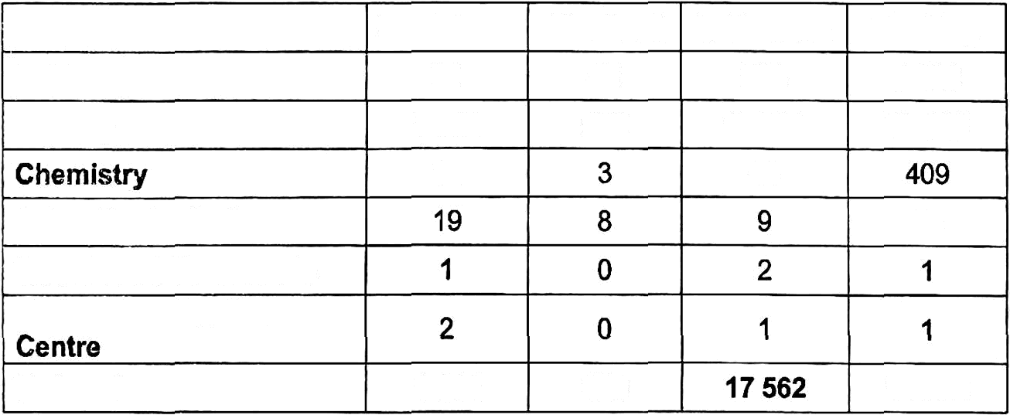
(2)(a) The South African Police Service (SAPS), does not have dedicated learning po gammes that deal with the guidelines of the management of survivors of sexual violence. However, the following learning

2

programmes incorporate the guidelines of the management of surViVors of sexual violence:
  - National Victim Empowerment.
  - First Responder to Sexual Offences.
  - Sexual Offences course for investigating officers.
  - Vulnerable Children.
  - Family Violence, Sexual Offences and Child Protection.
  - Domestic Violence.
  - Children and Youth at Risk.
- Human Rights in Policing.

(2)(a)(i)(ii)
A total of 10 282 SAPS members were trained and the details are as follows:

Province Number of Police Stations  Gauteng  KwaZulu-Natal 186 |  | Number of Police Officers Trained  3 746  2 342
Eastern Cape 172 |  | 794
North West | 80 | 705
Free State | 100 | 964
Western Cape | 113 | 692
Northern Cape | 81 | 415
Limpopo | 91 | 358
Mpumalanga | 61 | 157
Head Office | Not applicable | 109
Total | 1 029 | 10 282

3

(2)(b) From 1 April 20219 to 5 May 2021, a total number of 9 985 SAPS members were trained. The details, per training intervention, is reflected
in the table below:

Training Intervention |  | Number of Lea‹zi6fg
Natlonal Victim Empowerment |  | 1 021
First Responder to Sexual Offences |  | 1 929
Sexual Offences course for investigating Officers | 762
Vulnerable Children | 1 926
Family Violence, Sexual Offences and Child Protection | 175
Domestic Violence | 2 479
Children and Youth at Risk | 897
Human Rights in Policing | 796
Total | 9 985

- The number of facilitators, for each Learning Programme, is reflected in the table below:

Facilitators of Each Training in each case
Course Description | Number of Facilitators
4440 Domestic Violence and Amp Vulnerable Group LP | 37
3797 Family Violence Child Protection and Sexual TTT | 21
3521 Vulnerable Children Programme TTT | 84
3471 First Responder Sexual Off LP Programme TTT | 94
3407 Human Rights In Policing Learn Prog TTT | 100
3376 Children and Youth at Risk TTT | 133
3205 Human Rights and Amp Pol TTT Refresher | 29
3203 Human Rights Policing TTT | 89
3131 Victim Empowerment Programme: TTT | 199
3130 & 4632 Domestic Violence Learn Prog TTT | 339
Total 1 125

The namelist of facilitators, is attached as Annexure A.

- The duction of the Training Interventions are as folloWs!

Training lntemention
National lctim Empowerment
Fimt Responder to Sexual O9ences
Sexual Oüences œurse for lnvestigaüng Officers Vulneable Children
Family Violence, Sexual Ofiences and Child

Protection
Domestic Violence
Duraüon of Training
5 days
5 days
10 days
5 days
4 weeks
5 days

Children and Youth at Risk
( Human Rights in Policing
da5n
5 days
)

- The following Training Interventions have been planned to capacitats SAPS members, in the 2021/2022 financial yeac

Protection
Training intervention | Number of Trainees
National Victim Empowerment | 752
First Responder to Sexual O€ences | 1 099
Sexual Offences course for Investigating Officers | 656
Vulnerable Children | 890
Family Violence, Sexual OKences and Child  Domestic Violence | 210  1 513
Children and Youth at Risk | 598
) Human Rights in Policing | 310
( Total 6 028

Reply to question 1158 recommended/

GENERAL AFRICANPOLICESER VICE
K
0
E(SO G)
SI
R:
U

Reply to question 1158 approved/Preo

MINIST OF POLICE
GENERA H C LE, MP

