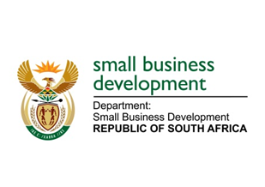
NATIONAL ASSEMBLY
QUESTIONS FOR WRITTEN REPLY
DUE TO PARLIAMENT ON FRIDAY, 26 JUNE 2020

1156. Mr W W Wessels (FF Plus) to ask the Minister of Small Business Development:

(1) With reference to her reply to question 916 on 5 June 2020, what (a) is the name of each company from which the specified goods and/or services were purchased, (b) is the amount of each transaction and (c) was the service and/or product that each company rendered;
(2) whether she will make a statement on the matter? NW1456E

REPLY:
- (a) (c) The following goods were procured:
- 75 Laptops and 75 Laptop bags from Massmart Stores for a total of R682 350.00.
- 75 Data cards and 75 Wi-Fi routers through the RT 15/2016 (Vodacom) for R43 038.75.
- 1000 Masks from Hlathi Developments and Enterprises (Pty) Ltd for R35 750.00
- No

