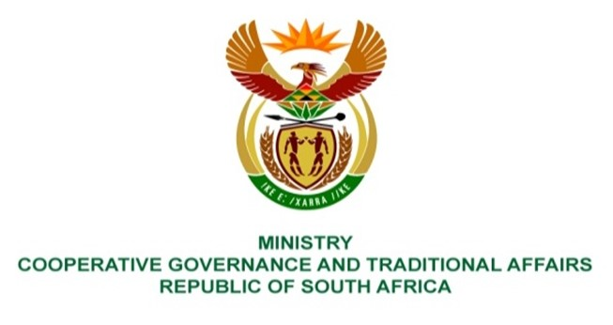

NATIONAL ASSEMBLY
QUESTIONS FOR WRITTEN REPLY

QUESTION NUMBER 1148
DATE OF PUBLICATION: 07 MAY 2021

QUESTION:

1149. Ms E R J Spies (DA) to ask the Minister of Cooperative Governance and Traditional Affairs:
(1) What steps will municipalities take to protect poor and indigent households following the 16% Eskom tariff increase;
(2) whether electricity tariff subsidies will be extended to households which lost income due to job losses caused by the COVID-19 pandemic; if not, why not; if so, what are the relevant details? NW1338E

REPLY:

- The Department provides support and guidance to all municipalities with regards to the provision of FBE to indigent households, through the regular monitoring of monthly FBE executive summary reports reflecting transactions for that particular month, quarterly reports reflecting a list of municipalities that are in arrears on their FBE accounts and quarterly reports reflecting details of access/collection of FBE tokens per municipality. This assists with identifying municipalities that are constantly in arrears especially in light of the annual rate increment and enable the necessary interventions to be effected. It further assists with the identification of indigent households not collecting their FBE thus not benefiting from the provision of FBE and enable the necessary interventions to be effected.

The Department works closely with Eskom (where Eskom is the licensed service provider), Provincial COGTAs and Municipalities; with the objective being to ensure that municipalities provides FBE to all qualifying indigent households receive FBE guided by the FBE Funding Agreement.

- No, there is no specific electricity tariff subsidy to the households that lost their jobs due to Covid-19 Pandemic. However, any household that requires subsidy for basic services is required to register at the municipality for free basic services subject to them meeting the criteria utilized for eligibility to receive the subsidy.

BACKGROUND INFORMATION:

The government’s intention is to provide support to municipalities by facilitating the provision of free basic services, namely: free basic water, free basic electricity, free basic sewerage and sanitation, and free basic solid waste management services to all qualifying households/consumers. The Electricity Basic Services Support Tariff (EBSST) policy introduced by the Department of Energy prescribes that 50kWh per provided to indigent households connected to the national grid on a monthly basis. The provision of FBE is funded through the Local Government Equitable Share (LGES) which augments municipal own revenues, to assist municipalities in providing free basic services to indigent housholds.

The Department of Cooperative Governance’s (DCoG) monitoring of the provision of FBE in Eskom supply areas is based on the FBE Funding Agreement between Eskom and the respective municipalities. Eskom is a licensed service provider to provide FBE to 213 municipalities across the country. It is critical to note that the absence of signed Funding Agreements or SLAs makes it difficult for the DCoG to intervene when there are disputes, such as delays by municipalities in paying for services rendered by Eskom as well as the identification of indigent households not collecting their FBE tokens. This has a negative impact on the provision of FBE.

The current three-year contract cycle commenced on 1July 2018 and will end on 30 June 2021. The Department and Eskom are busy engaging on processes to facilitate the renewal fo the current multi-year Funding Agreement that is due to commence from 1 July 2021 and end 30 June 2024.

The increase in municipal debt and its effects has been reiterated by the Minister of Cooperative Governance and Traditional Affairs (COGTA) and has been declared as an enormous challenge that has resulted in the disconnection of electricity of some indigent households. Poor communities are the ones who are affected the most by these disconnections and are deprived of their basic needs as reflected in the National Development Plan. Municipalities with escalating outstanding are constantly encouraged by the Department, to settle their FBE debt on time to avoid disputes and disconnections. It must be emphasized that municipalities, need to equally pay Eskom for the services rendered on their behalf for the provision of FBE to indigent households within their municipal jurisdiction.

