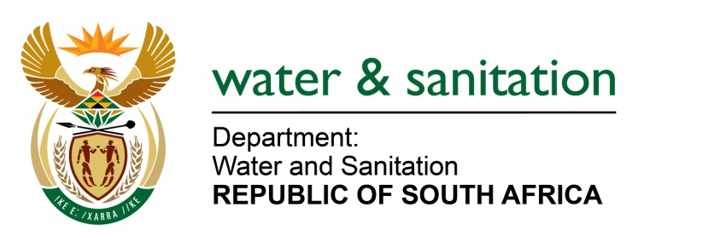

NATIONAL ASSEMBLY

FOR WRITTEN REPLY

QUESTION NO 1145

DATE OF PUBLICATION IN INTERNAL QUESTION PAPER: 12 MAY 2017
(INTERNAL QUESTION PAPER NO. 16)

1145. Mr L J Basson (DA) to ask the Minister of Water and Sanitation:

(a) How many requests for quotes exceeding the value of R10 million were made by Rand Water in the (i) 2014-15, (ii) 2015-16 and (iii) 2016-17 financial years and (b) in each case, (i) on what date was the money paid, (ii) what was the value of each transaction, (iii) what was the plant code and (iv) what was the nature of the project in each case? NW1285E
---00O00---
REPLY:
(a) The were no requests for quotes exceeding the value of R10 million were made by Rand Water in the 2014-15; a total of thirteen (13) quotes were made for the 2015- 16 and a total of seventeen (17) quotes were made for the 2016-17 financial years.

(b) Refer to Annexure A which outlines the dates, value and description of projects.
---00O00---

