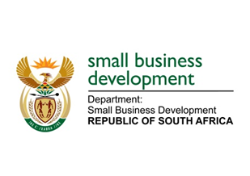
NATIONAL ASSEMBLY
QUESTION FOR WRITTEN REPLY
DUE TO PARLIAMENT: FRIDAY, 14 APRIL 2023

“1143. Inkosi R N Cebekhulu (IFP) to ask the Minister of Small Business Development:
Given that the Power Purchase Product (PPP) programme is an immediate relief for formal and informal enterprises, with the aim to support small, medium and micro enterprises with alternative energy generating equipment (details furnished), (a) where did her department source the funding from for the PPP programme and (b) how has her department (i) made the public aware of (aa) the specified programme and (bb) how to access it and (ii) use the programme to support local suppliers and/or service providers?” NW1283E

REPLY:
The Power Purchase Product is an interim measure to provide immediate and alternative relief for small enterprises to mitigate against the effect of loadshedding.
- Funding for this relief will be sourced from various Small Business Development Portfolio’s (Department of Small Business Development [DSBD], the Small Enterprise Development Agency [Seda] and the Small Enterprise Finance Agency [sefa]) existing programmes as part of reprioritisation of funds.
(b)(i) The Minister of Small Business Development made a public announcement of the product in February 2023.
(b)(i)(aa) Following the Minister’s pronouncement, consultation with the ecosystem players continued.
(b)(i)(bb) Once the funding has been approved accordingly by National Treasury in terms of PFMA, another announcement will be made in terms of how the scheme is going to be accessed and the application procedures. Applications will be done through the Small Enterprise Finance Agency (Sefa) and Small Enterprise Development Agency (Seda)
(b)(ii) As part of the plan, the Department is working with various industry players to identify innovative ways to ensure the sustainability of the programme. The plan is to develop these ideas and eventually deploy them as part of the programme and to ensure the stimulation of the suppliers including the installers.

