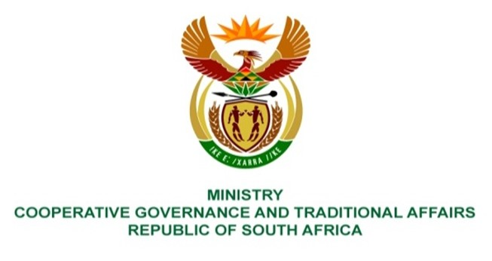

NATIONAL ASSEMBLY
QUESTIONS FOR WRITTEN REPLY

QUESTION NUMBER 1143
DATE OF PUBLICATION: 07 MAY 2021

1143. Mr H S Gumbi (DA) to ask the Minister of Cooperative Governance and Traditional Affairs:
What (a) is the total amount that has been spent on (i) water tankers and (ii) bulk water infrastructure in Ward 3, uMzinyathi, in the eThekwini Metropolitan Municipality in each financial year since 2010?

REPLY

1143

Financial year | Description | Project No. | YTD Actuals (at 30 April 2021) | Total per FY in  Rm
2020/21 | MZINYATHI | X7533 | -
 | ETAFULENI TOWNSHIP | X5653D | 0.185
 |  |  |  | 0.185
2019/20 | Intathakusa ET & Outlet pipeline | X5028B | 2.706
 | MZINYATHI,EMAQADINI RETICULATION | X7533 | 8.774
 | Umzinyathi - 16 Water tankers |  | 32.120
 |  |  |  | 43.600
2018/19 | Intathakusa ET & Outlet pipeline | X5028B | 9.997
 | Etafuleni Township | X5653 | 0.111
 | Intathakusa elevated tower & outlet pipeline | X5028A | 3.746
 | Umzinyathi - 15 Water tankers |  | 27.375
 |  |  |  | 41.229
2017/18 | Intathakusa ET & Outlet pipeline | X5028B | 0.011
 | Mzinyathi infill project | X6540 | 0.001
 | Intuthuko infills | X4506A | -
 | Umzinyathi - 12 Water tankers |  | 19.710
 |  |  |  | 19.722
2016/17
 | Intathakusa ET & Outlet pipeline | X5028B | 0.066
 | Etafuleni Township | X5653B | 0.737
 | Umzinyathi - 10 Water tankers |  | 14.600
 |  |  |  | 15.403
2015/16
 | INTHUTHUKO WATER INFILLS |  | 0.003
 | Intathakusa Project |  | -
 | Umzinyathi - 10 Water tankers |  | 12.775
 |  |  |  | 12.778
2014/15 | Ekukhanyeni/Mzinyathi | X3675 | 0.011
 | Intuthuko Water | X4506 | 0.180
 | Mzinyathi Baseline Survey | X5720 | 0.570
 |  |  |  | 0.761

BACKGROUND INFORMATION:

It is to be noted that parliamentary question require information since 2010, however information submitted by the Ethekwini Metro is for period since 2011/12 financial year. According to the Metro, information before 2011/12 is not readily available and therefore will require more time to be extracted and submitted

