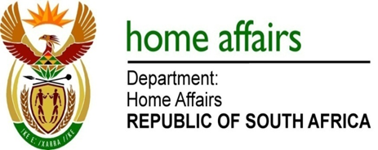

NATIONAL ASSEMBLY

QUESTION FOR WRITTEN REPLY

QUESTION NO. 114

DATE OF PUBLICATION: THURSDAY, 8 FEBRUARY 2018

INTERNAL QUESTION PAPER 1 OF 2018

114. Mr J Vos (DA) to ask the Minister of Home Affairs:

(a) What number of international trips did (i) she and (ii) the Deputy Minister undertake since 31 March 2017, (b) what was (i) the destination and (ii) purpose of each trip and (c) what is the detailed breakdown of all costs incurred in respect of each trip? NW120E
REPLY:

(a)(i) Former Minister of Home Affairs, Prof. H B Mkhize, MP undertook 4 international visits during her tenure from 31 March 2017 to 17 October 2017. The information is as follows:

TRAVEL DATE | (b)(i) DESTINATION | (b)(ii) PURPOSE | (c) AMOUNT
26.06-01.07.2017 | Berlin -Germany | Global Forum on Migration and Development | R 80 917.43
19-22.07.2017 | Dar Es Salaam - Tanzania | SADC Ministerial Committee of the Organ meeting | R 18 292.29
02-04.09.2017 | Ezulwini - Swaziland | Ministerial Migration Dialogue for Southern Africa (MIDSA) | R 6 181.69
30.09-05.10.2017 | Geneva - Switzerland | 68th Session of the UNHCR ExCom for Refugees in Geneva | R 80 870.09
Total |  |  | R 186 261.50

(a)(i) Ms Dlodlo, MP who was subsequently appointed Minister of Home Affairs from 18 October 2017 to 26 February 2018 did not take any international trips.

(a)(ii) The Deputy Minister of Home Affairs, Ms F Chohan, MP undertook 3 international visits since 31 March 2017 to date. The information is as follows:

TRAVEL DATE | (b)(i) DESTINATION | (b)(ii) PURPOSE | (c) AMOUNT
30.09-08.10.2017 | Geneva - Switzerland | 68th Session of the UNHCR ExCom for Refugees in Geneva | R 94 821.03
19.10-22.10.2017 | Kigali - Rwanda | African Union Commission Technical Committee on Migration of Refugees and Displaced Persons | R 35 589.30
15.12.2017 | Maseru – Lesotho | Bilateral meeting on Immigration issues | R 5 704.71
Total |  |  | R 136 115.04

