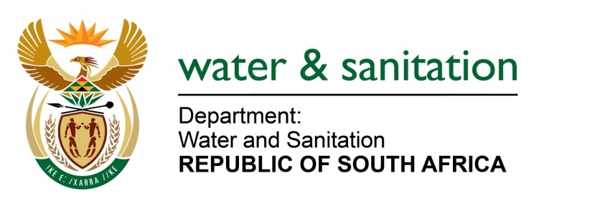

NATIONAL ASSEMBLY

FOR WRITTEN REPLY

QUESTION NO 1136

DATE OF PUBLICATION IN INTERNAL QUESTION PAPER:
(INTERNAL QUESTION PAPER NO. 12) 31 MARCH 2023

1136. Ms S A Buthelezi (IFP) to ask the Minister of Water and Sanitation:
What are the relevant details of the (a) memorandum of understanding (MoU) that was signed between the Government and Finland and (b) renewed MoU with the Netherlands? NW1276E
---00O00---

MINISTER OF WATER AND SANITATION

- The memorandum of understanding (MoU) between the Government of Finland and Republic of South Africa was signed at the United Nations (UN) Water Summit in New York on 22 March 2023. The MoU focuses on water resource management with the following as agreed areas of cooperation:
- Adaptation and mitigation of climate change in water resources management.
- Transboundary water management.
- Water supply services covering supply, sanitation, reuse and policies.
- Governance management and technologies.
- Response in water-energy nexus for mutual benefit.
- Hydro informatics including monitoring, data transfer and platforms, modelling and assessment.
- Education and capacity building.
- Cooperation on other areas of mutual interest.

- The renewed Memorandum of Agreement between the Government of the Netherlands and the Republic of South Africa, also on water resources management, was signed on 22 March 2023 in New York. The MoU focuses on water resource management with the following as agreed areas of cooperation: Strengthening water governance including strategies, planning and operations.
- Monitoring and information management.
- Climate change adaptation, water management and resilient.
- Water management in transboundary/river basins.
- Water efficiency, water re-use and use of alternative water resources in municipalities, agricultural and industry.
- Groundwater management.
- Wastewater treatment, agriculture, domestic and industrial.
- Sanitation and drinking water supply.
- Implementation of the Water and Sanitation Master Plan of South Africa.
- Capacity building and knowledge exchange in municipal water management and supply.

---00O00---

