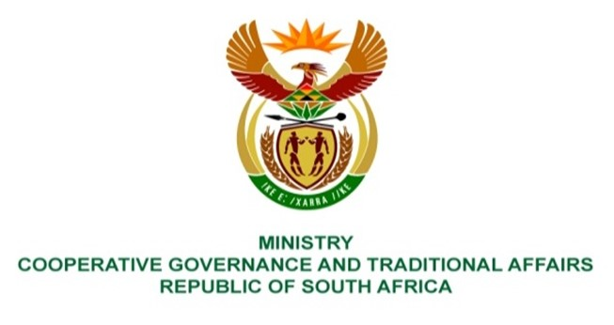

NATIONAL ASSEMBLY
QUESTIONS FOR WRITTEN REPLY

QUESTION NUMBER 1136
DATE OF PUBLICATION: 14 MAY 2021

QUESTION:

1136. Mr N P Masipa (DA) to ask the Minister of Cooperative Governance and Traditional Affairs:

QUESTION:
What is the (a) extent of the commonage land in the Western Cape and (b) current usage of the commonage land;
(2) whether the commonage land has water rights to allow farming to take place; if not, what steps will her department take to ensure that there are water rights; if so, what are the relevant details;
(3) whether there are farming activities taking place on the commonage land; if not, why not; if so, what farming activities are taking place on the pieces of land;
(4) whether she will furnish Mr N P Masipa with the relevant information regarding (a) land that has been invaded and (b) the action(s) that were taken regarding the situation; if not, why not; if so, by what date
NW1323E

REPLY:
The issues relating to the commonage land are managed and administered by the Department of Rural Development and Land Reform. The Honourable member is advised to direct this question to the said department.

