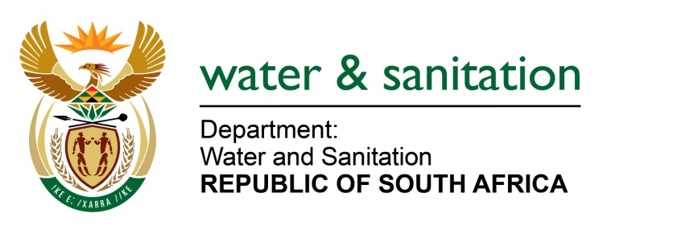

NATIONAL ASSEMBLY

FOR WRITTEN REPLY

QUESTION NO 1134

DATE OF PUBLICATION IN INTERNAL QUESTION PAPER: 25 MARCH 2022
(INTERNAL QUESTION PAPER NO. 12)

1134. Mr L J Basson (DA) to ask the Minister of Water and Sanitation:
What are the (a) reasons that the situation of empty reservoirs in the south of Johannesburg which began five years ago has not been addressed and (b) details of the water and/or reservoirs challenges faced by residents because the Meyershill and South Hills reservoirs were empty since in February 2022 and residents did not have a drop of water for nine days, and that there has been no water in the areas of Linmeyer, Risana, South Hills and Oakdene since 10 March 2022 as the reservoirs are also empty? NW1386E
---00O00---
MINISTER OF WATER AND SANITATION
Rand Water provides potable water to the City of Johannesburg. Over the past couple of years Rand Water experienced failures of bulk electrical and mechanical equipment at the Rand Water purification works and main pump stations. Interruptions at the Zuikerbosh purification plant impacts on Rand Water’s Palmiet and Swartkoppies pump stations. These pump stations supply water to the Klipriviersberg, Meyershill and Forest Hill reservoirs.
Johannesburg Water pumps water from the Rand Water Meyershill reservoir to the South Hills towers to supply water to Linmeyer, Risana, South Hills and surrounding areas. Johannesburg Water also pumps water from the Rand Water Forest Hill reservoir to the Forest Hill tower which provide water the Oakdene and surrounding areas.

Due to the electrical and mechanical failures at the works and the pump stations at Rand Water, the water levels at reservoirs are reduced to very low levels or run empty. When the water levels from the reservoirs are too low, the Johannesburg Water pumps are damaged.
To safeguard the pumps against the damage, Johannesburg Water switches off its pump stations until reservoir levels can be stabilised. During the period when the pumps are switched off, this results in water interruptions for the areas dependent on the Klipriviersberg, Meyershill and Forest Hill reservoirs.
Since February 2022 Rand Water had a number of failures at their Zuikerbosh plant as well as the Palmiet pump station which affected water supply capability to the South of Johannesburg; especially the Meyershill reservoir; which then impacted on the South Hills tower supply. The failures resulted from electricity supply failures, transformer failures as well as pump failures on various occasions. The duration of the interruptions would be as long as 5 days over which Rand Water managed to build sufficient capacity at its reservoirs. The City of Johannesburg provides water through alternative means to affected areas when there are disruptions.
During the last incident in the beginning of March 2022, arrangements were made for Johannesburg Water to pump water directly from the inlet pipe works at the Meyershill reservoir to restore water supply in the South Hills area. This stabilised water supply to the South Hills area since mid-March 2022 and also allowed Rand Water to stabilise levels of water at the servoir l at the Meyershill reservoir.

---00O00---

