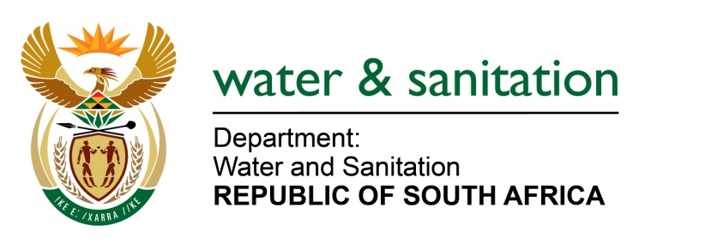

NATIONAL ASSEMBLY

FOR WRITTEN REPLY

QUESTION NO 1131

DATE OF PUBLICATION IN INTERNAL QUESTION PAPER: 25 MARCH 2022
(INTERNAL QUESTION PAPER NO. 12)

1131. Mr L J Basson (DA) to ask the Minister of Water and Sanitation:

(1) Whether he intends to transfer the bulk water services of the Ugu District Municipality to a water board as the water crisis in the specified municipality has been ongoing for the past six years and vast areas of the municipality are currently without water; if not, why not; if so, what are the relevant details.

(2) whether his department is providing any form assistance in order to resolve the Ugu District Municipality water crisis; if not, why not; if so, what are the relevant details?
---00O00---

NW1383E
MINISTER OF WATER AND SANITATION

- If a water services authority has not effectively performed its water services function, the Minister of Water and Sanitation is able to intervene in terms of Section 63 of the Water Services Act, in consultation with the Minister for Co-operative Governance and Traditional Affairs, and by requesting the Province to intervene in terms of section 139 of the Constitution. If the section 139 intervention is unsuccessful, the Minister of Water and Sanitation can assume responsibility for the water services function.
In this regard, in December 2021 the Premier of KwaZulu-Natal established an inter-Ministerial task team to determine the root causes of water supply interruptions in the various supply systems, develop implementable interventions, and monitor the progress made with implementation of the interventions. In addition, a Water Supply Challenges WAR room has been established and meets every week to ensure interventions are implemented and to monitor progress on projects.

In terms of Section 154 of the Constitution, the Department of Water and Sanitation and the Provincial Department of Cooperative Governance and Traditional Affairs have allocated financial and human resources to support and strengthen the capacity of the Ugu DM to manage their own affairs, exercise powers and perform their functions efficiently.

The Minister of Water and Sanitation is not mandated to transfer the Ugu District Municipality’s bulk water function to a water board. The appointment of a bulk water services provider by the Ugu DM would need to follow the provisions of Section 78 of the Municipal Systems Act.

- The DWS is providing assistance to the Ugu DM. The DWS is partaking on the Inter-Ministerial Task Team and the WAR room meetings and has allocated funding to the Ugu DM through the Water Services Infrastructure Grant (WSIG). The allocations from the 2021/22 to 2022/23 financial years are as follows:

Financial Year | Amount
2021/22 | R72 350 000
2022/23 | R60 000 000
2023/24 | R70 000 000
Total | R202 350 000

---00O00---

