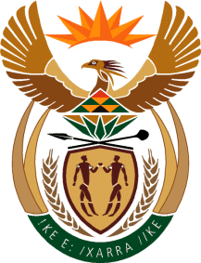

MINISTER OF TOURISM
REPUBLIC OF SOUTH AFRICA

Private Bag X424, Pretoria, 0001, South Africa. Tel. (+27 12) 444 6780, Fax (+27 12) 444 7027
Private Bag X9154, Cape Town, 8000, South Africa. Tel. (+27 21) 469 5800, Fax: (+27 21) 465 3216

NATIONAL ASSEMBLY:

QUESTION FOR WRITTEN REPLY:
Question Number: 1131
Date of Publication: 11 October 2019
NA IQP Number: 18
Date of reply: 17 November 2019

Mr G R Krumbock (DA) to ask the Minister of Tourism:
(a) On what date was the Tourism Economic Framework finalised, (b) what are the main drivers of the framework, (c)(i) how is the framework communicated and (ii) to whom and (d) how is the execution of the framework (i) monitored and (ii) evaluated? NW2291E

Reply:

The Department of tourism does not have a Tourism Economic Framework.

- – (d) Not applicable

