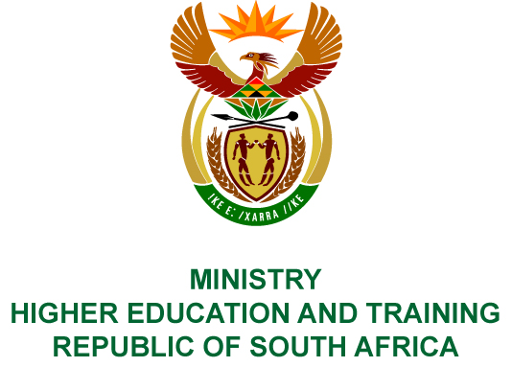
Private Bag X893, Pretoria, 0001, Tel (012) 312 5555, Fax (012) 323 5618
Private Bag X9192, Cape Town, 8000, Tel (021) 469 5150, Fax: (021) 465 7956
Memorandum from the Parliamentary Office
NATIONAL ASSEMBLY
FOR WRITTEN REPLY
QUESTION 1127
DATE OF PUBLICATION OF INTERNAL QUESTION PAPER: 20/04/2018
(INTERNAL QUESTION PAPER NO 12 OF 2018)
Mr A P van der Westhuizen (DA) to ask the Minister of Higher Education and Training:
Whether her department and/or the National Student Financial Aid Scheme or any other body funded by her department laid charges with the relevant law enforcement agencies against those individuals who had allegedly committed fraud and who were identified in the Nexus Forensic Services report submitted to her department earlier in 2018; if not, (a) why not and (b)(i) how and (ii) by whom will this matter be handled in the future; if so, what number of individuals were named in the charges? NW1220E
REPLY:
Nexus Forensics Services provided the Department with an extensive report containing findings and recommendations, which the Department is considering. The Department will revert to Parliament as soon as this process is finalised.

