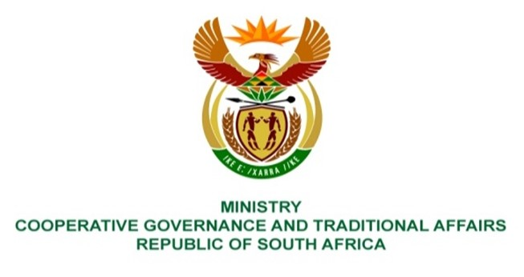

NATIONAL ASSEMBLY
WRITTEN

QUESTION NUMBER 1125
DATE OF PUBLICATION: 25 MARCH 2022

QUESTION:

1125. Ms A M M Weber (DA) to ask the Minister of Cooperative Governance and Traditional Affairs:
(1) What are the reasons that the (a) report of the forensic audit into the affairs of Dipaleseng Local Municipality that was commissioned by the former Member of the Executive Council in Mpumalanga has not been tabled in the specified local municipality (details furnished) and (b) recommendations were not implemented;
(2) How was the (a) Chief Financial Officer (CFO), (b) the Municipal Manager and (c) others in director positions allowed to renegotiate salary increases that were way above their salary scale as stipulated in the local government upper limits;
(3) Whether, given that the specified employees caused an unnecessary and unjustifiable expense for the municipality, she will ensure that monies paid in excess of the stipulated salaries as detailed in the section 106 of the Local Government: Municipal Systems Act, Act 32 of 2000, report must be recovered from the former employees; if not, why not; if so, by what date;
(4) Whether she will ensure that allegations of financial misconduct levelled at the former CFO (name furnished) by a certain company (name furnished) will be investigated further; if not, why not; if so, what are the relevant details;
(5) What measures will she put in place to strengthen the oversight roles in local municipalities across the Republic? NW1377E

REPLY:

The response below was provided by the Mpumalanga province:
(1) (a) The report was tabled before the municipal Council on 10 February 2022.
(b) The municipal Council discussed the report and developed an action plan on how they will implement the recommendations.
(2) The matter of the salary increases and other matters were some of the reasons why the provincial department instituted an investigations in terms of section 106 (1)(b) of the Municipal Systems Act 2000 at the municipality. The report has indicated that there were clear breaches of the Local Government: Municipal Systems Act, 2000 and regulations on the appointment and conditions of employment of Senior Managers. The recommendations have been made that all monies paid unlawfully as a result of the illegal salary increases must be paid back to the municipality and that disciplinary action must be taken against all those implicated.
(3) As indicated above, the investigation conducted has revealed that there were clear breaches of the Local Government: Municipal Systems Act, 2000 and regulations on the appointment and conditions of employment of Senior Managers. The recommendations have been made that all monies paid unlawfully as a result of the illegal salary increases must be paid back to the municipality and that disciplinary action must be taken against all those implicated. The monies will be recovered and the municipality has started the process of recovering such monies.
(4) The recommendations of the investigation report are clear on what actions need to be taken on each of the findings in the report. Some matters will be dealt with by the municipality, whilst those with criminality will be handed over to law enforcement agencies for further action. The matter of the former CFO and the company implicated is one of those which will be investigated further by the law enforcement agencies.

(5) Workshops have been conducted in all provinces targeting relevant officials in municipalities on the regulations on the appointment and conditions of employment of Senior Managers. The Local Government Anti-Corruption Forum will also assist in terms of strengthening oversight on corruption related matters. Working with MECs for COGTA in the provinces we will ensure that there is compliance to the regulations.

