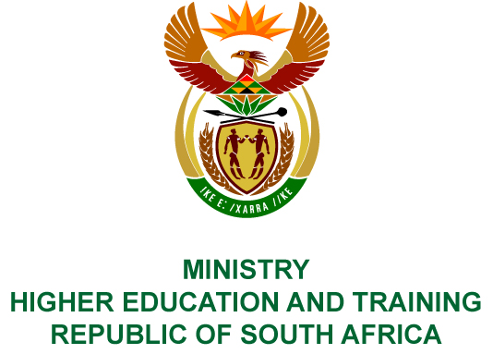
Private Bag X893, Pretoria, 0001, Tel (012) 312 5555, Fax (012) 323 5618
Private Bag X9192, Cape Town, 8000, Tel (021) 469 5150, Fax: (021) 465 7956
Memorandum from the Parliamentary Office
NATIONAL ASSEMBLY
FOR WRITTEN REPLY
QUESTION 1125
DATE OF PUBLICATION OF INTERNAL QUESTION PAPER: 20/04/2018
(INTERNAL QUESTION PAPER NO 12 OF 2018)
Mr A P van der Westhuizen (DA) to ask the Minister of Higher Education and Training:
With reference to each community education and training college, (a) what number of subjects did learners enrol for in respect of the (i) Senior Certificate and (ii) National Senior Certificate examination cycles in each of the past three academic years and (b) of the specified subjects, (i) what number of subjects were eventually written and (ii) what number of students achieved marks (aa) equal to 40% and above and (bb) between 30% and 40% in each case?
NW1218E
REPLY:
The Department of Basic Education is best placed to respond to this question, as it is the custodian of both the Senior Certificate and National Senior Certificate examinations. The Community Education and Training Colleges through their Community Learning Centres provide opportunities to individuals for enrolment into these examinations.

