MINISTER IN THE PRESIDENCY: REPUBLIC OF SOUTH AFRICA
Private Bag X1000, Pretoria, 0001, Union Buildings, Government Avenue, PRETORIA Tel: (012) 300 5200, Website: www.thepresidencY.oov.za

NATIONAL ASSEMBLY QUESTIONFORWRITTENREPLY QUESTION NUMBER: 1124
DATE OF PUBLICATIONS: 11 October 2019

1124. Dr L A Schreiber (DA) to ask the Minister in The Presidency:

(a) What is the name of each (i) Director-General and (ii) Head of Department who failed to submit mid-term reviews by 31 September 2019 as agreed to in the performance monitoring system for the 2018-19 financial year and (b) in which (i) national and (ii) provincial government department is each specified Director-General and Head of Department employed? NW2283E

REPLY:

Non-submission of 2018/19 DGs/HoDs midterm review

No. |  | National/  Provincial |  | Department |  |  |  |  | Name of HoD |  | Half-yearly  Review 18/19
1 |  | Eastern Cape |  | Econ Affairs, Env &  Tourism |  |  |  |  | Mr B Gxilishe |  | Not submitted
2 | ) | Eastern Cape | ) |  | Health |  | ) |  | DrT Mbengashe | ) | Not submitted
3 |  | Eastern Cape |  |  | Local Gov  Affairs | & Traditional |  |  | Ms G. Gumbi- ”  Masilela |  | Not submitted

- Eastern Cape Roads & Public Works
- Eastern Cape Rural Development &
Agrarian Reform
Mr J Mlawu Mr L Ngada
Not submitted Not submitted

6 | Eastern Cape | Sport, Recreation, Arts  & Culture | Mr M Matutu | Not submitted
7 | Eastern Cape | Transport | Ms Irene  Mpolweni | Not submitted
8 | Free State | Office of the Premier | Mr KF  Ralikontsane | Not submitted
9 | Gauteng | Agric & Rural  Development | Mr. Nhlakanipho  Nkontwana | Not submitted
10 | Gauteng | Community Safety | Ms. Yoliswa  Makhasi | Not submitted
11 | Gauteng | E-Government | Mr B Ngobeni | Not submitted
12 | Gauteng | Health | Prof. Mkhululi  Lukhele | Not submitted
13 | Gauteng | Human Settlements | Ms Mathilda  Gasela | Not submitted
14 | Gauteng | Infrastructure  Development | Mr 8  Netshiswinzhe | Not submitted
15 | Gauteng | Cooperative  Governance & Traditional Affairs | Ms. Thandeka  Mbassa-Sigabi | Not submitted
16 | Gauteng | Office of the Premier | Ms Baleni | Not submitted
17 | Gauteng | Social Development | Mr M.Mampuru | Not submitted
18 | Gauteng | Sport, Arts, Culture &  Recreation | Ms. Monica  Newton | Not submitted
19 | Gauteng | Treasury | Ms. Nomfundo  Tshabalala | Not submitted
20 | KwaZuIu-  Natal | Econ Dev, Tourism &  Env Affairs | Ms P Ncapayi | Not submitted
21 | Limpopo | Econ Dev, Environment  & Tourism | Mr Solly  Kgopong | Not submitted
22 | Limpopo | Cooperative  Governance, Human Settlements & Traditional Affairs | Ms NR Dumalisile | Not submitted
23 | National | Agric, Forestry &  Fisheries | Mr MM  Mlengana | Not submitted
24 | National | Co-operative  Governance | Mr DM  Mashitisho | Not submitted
25 | National | Correctional Services | Mr Arthur Fraser | Not submitted
26 | National | Defence (Secretary for | Dr Sam Gulube | Not submitted

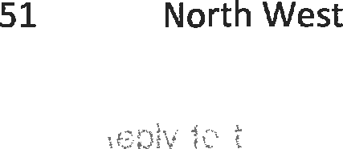
 |  | Defence)
27 | National | Environmental Affairs | Ms N Ngcaba | Not submitted
38 | National | Health | Ms P Matsoso | Not submitted
29 | National | Higher Education &  Training | Mr G Qonde | Not submitted
30 | National | Home Affairs | Mr M Apleni | Not submitted
31 | National | Independent Police  Investigative Directorate | Mr R McBride | Not submitted
32 | National | Justice and  Constitutional  Development | Mr V Madonsela | Not submitted
33 | National | Labour | Mr TM Lamati | Not submitted
34 | National | National Treasury | Mr D Mogajane | Not submitted
35 | National | Office of the Chief  Justice | Ms M  Sejosengwe | Not submitted
36 | National | Sport and Recreation SA | Mr EM Moemi | Not submitted
37 | National | Government Pensions  Administration Agency | Mr K G Sukdev | Not submitted
38 | Mpumalanga | Community Safety,  Security& Liaison | Mr Mthombothi | Not submitted
39 | Mpumalanga | Education | Mrs MOC  Mhlabane | Not submitted
40 | Mpumalanga | Treasury | Ms NZ Nkamba | Not submitted
41 | Mpumalanga | Health | Dr S. Mohangi | Not submitted
42 | Mpumalanga | Human Settlements | Mr Masange | Not submitted
43 | Mpumalanga | Public Works, Roads &  Transport | Ms SP Xulu | Not submitted
44 | Mpumalanga | Social Development | Mr MV Mahlalela | Not submitted
45 | North West | Community Safety &  Transport Management | Ms BA Mofokeng | Not submitted
46 | North West | Culture, Arts &  Traditional Affairs | Mrs SR Bapela | Not submitted
47 | North West | Economy & Enterprise  Development | LG Tshikovhi | Not submitted
48 | North West | Education & Sport  Development | SM Semaswe | Not submitted
49 | North West | Health | Dr AT Lekalakala | Not submitted
50 | North West | Local Govt & Human  Settlements | Mr PE Motoko | Not submitted
 |  | Office of the Premier | Dr Keneilwe L | Not submitted

 |  |  | Sebego
52 | North West | Public Works & Roads | Mr P Mothupi | Not submitted
53 | North West | Rural, Environment & Agricultural Development | Dr Mokaila | Not submitted
54 | North West | Social Development | Ms PD Mothobi | Not submitted
55 | North West | Tourism | Adv Hope Fiona  Neo Sephoti | Not submitted
56 | Northern  Cape | Agriculture, Land  Reform & Rural Development | Mr WVD Mothibi | Not submitted
57 | Northern  Cape | Cooperative Gov,  Human Settlement & Trad Affairs | Mr B Lenkoe | Not submitted
58 | Northern  Cape | Health | Mr S Jonkers | Not submitted
59 | Northern  Cape | Sports, Arts & Culture | Ms R Palm | Not submitted
60 | Northern  Cape | Transport, Safety &  Liaison | Mr MP Dichaba | Not submitted

DRAFTER OF THE REPLY
Name:
Designation:
Contacts:

Recommended / Not recommended

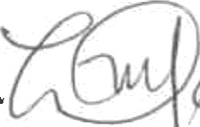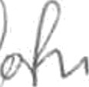
Director-General (DPME) Date:

Approved / Not approved

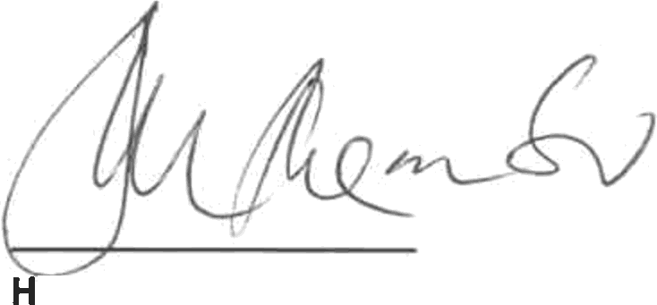

on. Jackson Mthembu, MP
Minister in The Presidency

Date: ,’

MINISTER IN THE PRESIDENCY: REPUBLIC OF SOUTH AFRICA
Private Bag X1000, Pretoria, 0001, Union Buildings, Government Avenue, PRETORIA Tel: (012) 300 5200, Website: www.theDresidency.oov.za

NATIONAL ASSEMBLY QUESTION FOR WRITTEN REPLY QUESTION NUMBER: 1325
DATE OF PUBLICATIONS: 25 October 2019

1325. Dr L A Schreiber (DA) to ask the Minister in The Presidency:

With reference to his reply to question 834 on 2 October 2019, what is the detailed breakdown of the amounts spent on each former principal and spouse since 1 April 2016 in terms of (a) hotel accommodation, (b) private accommodation, (c) alcohol, (d) catering, (e) entertainment, (I)(i) commercial and (ii) military flights, (g) vehicle transport and (h) security?
NW2537E

Response

Benefits applicable to Former Presidents and Former Deputy Presidents are prescribed in the Policy on the Benefits of Executive Office, dated March 2009. Benefits that are paid for from The Presidency budget in respect of Former Presidents and a Former Deputy Presidents include the following:-

  - Accommodation
  - Commercial flights
  - Vehicle transport

The travel and accommodation are paid in accordance with the policy, as former Presidents and Deputy Presidents support government programmes inside and outside the borders of the Republic of South Africa. The benefits are irrespective of whether or not the former Presidents and Deputy Presidents are on official or private duties as they are de facto ambassadors of the people of South Africa.

Military flights and Security services are paid for by the South African National Defence Force and South African Police Service respectively.

The policy is in line with what obtains in comparable countries the world over.

Please find attached breakdown of the amounts spent on each former principal and spouse since 2016

DRAFTER OF THE REPLY
Name: K Mashapha
Designation: Director Financial Administration
Contacts: 012 300 5998

Recommended

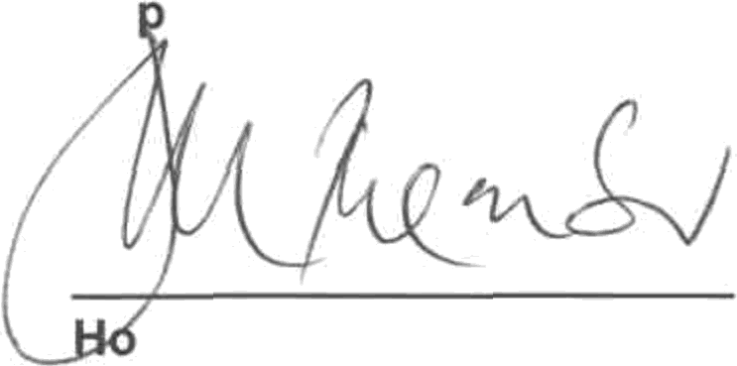
Director-General — The Presidency Date: /J //
Ap roved / NQ

n. Jackson Mthembu, MP Minister in Th Pre 'dency Date: g/ /

Question
Total |  |  |  | FY2016-17 |  |  |  | { |  |  | FYZ01&19
Former  President de Klerk |  | Spouses |  | Former  President de Klerk |  | Spouse |  | Former  President de Klerk |  | Spouse | President de Klerk |  | Former  President de Klerk | Spouse
R R R R R R R  R | 130987.32 | R R R R R R R R  R | 66437.12 | R R R R R R R  R | 46985.14 | R R R R R R R R  R | 12643.30 | R R R R R R R R  R | 16S64.92 | R R R R R R R R  R | R R R R R  R 50 768.32  R R  R | R -  R -  R -  R -  R -  R 37 538.88  R -  R -  R - | R R R R R  R 16 248.94  R R  R | R R R R R  R 16 254.94  R R  R

- For the period 01 April Z016to date, what is the detailed breakdown of amounts spent on each Former Principal and Spouse, in terms of

  - Hotel accomodation
  - Private accomodation
  - Alcohol
  - Catering
  - Entertainment I)(i) Commercial flights f(i)(i) Military flights
- Vehicle transport
- Security

- For the period 01 April 2O16to date, what is the detailed breakdown of amounts spent on each Former Principal and Spouse, in terms of
Total |  | FY2016-17 |  |  |  | FY2018-19 |  | FY201S-20
Former President Mbekl | Spouses | Former President Mbekl | Spouse | Former President Mbeki | Spouse | Former President Mbekl | Spouse | Former President Mbekl | Spouse

  - Hotel accomodation
R | 628 994.67 | R | 62 727.62 | R | 233 750.66 | R | 41 422.96 | R | 228 855.87 | R | - | R | 116 017.34 | R | 21 304.66 | R | 50 370.80 | R
R |  | R | - | R |  | R | - | R |  | R | - | R |  | R | - | R |  | R
R |  | R | - | R |  | R | - | R |  | R | - | R |  | R | - | R |  | R
R |  | R | - | R |  | R | - | R |  | R | - | R |  | R | - | R |  | R
R |  | R | - | R |  | R | - | R |  | R | - | R |  | R | - | R |  | R
R | 176 875.99 | R | 266 754.60 | R | 38 723.86 | R | 102 559.04 | R | 19 661.68 | R | 48 915.81 | R | 11 615.72 | R | 64 438.18 | R | 106 874.73 | R | 50 841.57
R |  | R | - | R |  | R | - | R |  | R | - | R |  | R | - | R |  | R
R | 468 777.42 | R | 117 848.19 | R | 106 112.02 | R | 35 961.32 | R | 110 539.17 | R | 387.77 | R | 56 851.50 | R | 62 509.96 | R | 195 274.73 | R | 18 989.14
R |  | R | - | R |  | R | - | R |  | R | - | R |  | R | - | R |  | R

  - Private accomodation
  - Alcohol
  - Catering
  - Entertainment I)(i) Commercial flighU f(i)(i) Military fiighU
- Vehicle transpon
- Security

Question
Total |  |  |  |  |  |  |  | FY2017-18 |  |  |  | FY2018-19 |  |  |  | FY2019-20
Former  President  Motlanthe |  | Spouses |  | Former  President Motlanthe |  | Spouse |  | Former  President Motlanthe |  | Spouse |  | Presldent Motlanthe |  | Spouse |  | President Motlanthe |  | Sgouse
R | 392 370.98 | R |  | R | 24 329.7S | R |  | R | 120 170.43 | R |  | R | 106 245.00 | R |  | R | 141 625.80 | R
R |  | R |  | R |  | R |  | R |  | R |  | R |  | R |  | R |  | R
R |  | R |  | R |  | R |  | R |  | R |  | R |  | R |  | R |  | R
R |  | R |  | R |  | R |  | R |  | R |  | R |  | R |  | R |  | R
R |  | R |  | R |  | R |  | R |  | R |  | R |  | R |  | R |  | R
R | 573 708.01 | R | 548 609.31 | R | 288 092.85 | R | 159 063.64 | R | 134 79S.04 | R | 126 602.50 | R | 7s szg.s6 | R | 183 794.95 | R | 71 490.26 | R | 79 148.22
R |  | R |  | R |  | R |  | R |  | R |  | R |  | R |  | R |  | R
R | 2 074 516.35 | R | 341 007.94 | R | 203 380.47 | R |  | R | 804 646.26 | R |  | R | 691 775.20 | R | 341 007.94 | R | 374 714.42 | R
R |  | R |  | R |  | R |  | R |  | R |  | R |  | R |  | R |  | R

For the period 01 Aprll 2016 to date, what is the detailed breakdown of amounts spent on each Former Principal and Spouse, in terms of

- Hotel accomodation
- Private accomodation
- Alcohol
- Catering
- Entertainment
I)(i) Commercial flights f(i)(i) Military flights
- Vehicle transpon
- Security

Question
Total |  |  |  | FYZ016-17 |  | FY2017-18 |  |  |  |  |  |  | FY2019-20
President Zuma |  | Spouses |  | Former President Zuma |  | President Zuma |  | Spouse | Former President Zuma |  | Spouse |  | Former President Zuma
R | 32299.75 | R |  | R | R | R |  | R | R | 32 299.75 | R | - | R |  | R
R |  | R |  | R | R | R |  | R | R |  | R | - | R |  | R
R |  | R |  | R | R | R |  | R | R |  | R | - | R |  | R
R |  | R |  | R | R | R |  | R | R |  | R | - | R |  | R
R |  | R |  | R |  | R |  | R | R |  | R | - | R |  | R
R | 285001.39 | R | 122248.47 | R | R | R | 20717.34 | R | R | 174839.55 | R | 43 305.55 | R | 89 444.50 | R | 78 942.92
R |  | R |  | R | R | R |  | R | R |  | R | - | R |  | R
R | 15052.27 | R |  | R | R | R | 14780.27 | R | R |  | R | - | R | 272.00 | R
R |  | R |  | R | R | R |  | R | R |  | R | - | R |  | R

For the period 01 April Z016 to date, what is the detailed breakdown of amounts spent on each Former Prindpal and Spouse, in terms of

- Hotel accomodation
- Private accomodation
- Alcohol
- Catering
- Entertainment
f)(i) Commercial flights f(i)(i) Military flights
- Vehicle transpon
- Security

For the period 01 April 2016 to date, what is the detailed breakdown of amounts spent on each Former Principal and Spouse, in terms of
Former DP Mlambo- Ngcuka |  | Spouses |  | Former DP Mlambo- Ngcuka |  | Spouse |  | Former DP Mlambo- Ngcuka |  | Spouse |  | Former DP Mlambo- Ngcuka |  | Spouse |  | Former DP Mlambo- Ngcuka |  | Spouse
R |  | R |  | R |  | R | - | R |  | R |  | R | - | R |  | R |  | R
R |  | R |  | R |  | R | - | R |  | R |  | R | - | R |  | R |  | R
R |  | R |  | R |  | R | - | R |  | R |  | R | - | R |  | R |  | R
R |  | R |  | R |  | R | - | R |  | R |  | R | - | R |  | R |  | R
R |  | R |  | R |  | R | - | R |  | R |  | R | - | R |  | R |  | R
R | 249 163.84 | R | 66 114.89 | R | 55 311.22 | R | 23 055.67 | R | 50 891.93 | R | 674.95 | R | 103 653.84 | R | 21 445.08 | R | 39 306.85 | R | 20 939.19
R |  | R |  | R |  | R | - | R |  | R |  | R | - | R |  | R |  | R
R | 524.00 | R |  | R |  | R | - | R | 524.00 | R |  | R | - | R |  | R |  | R
R |  | R |  | R |  | R | - | R |  | R |  | R | - | R |  | R |  | R

- Hotel accomodation
- Private accomodation
- Alcohol
- Catering
- Entertainment I)(i) Commercial flights I(i)(i) Military flights
- Vehicle transport
- Security

Quenlon
 |  | FY2016-17 |  | FY2017-18 |  | FY2018-19 |  | FY2019-20
fiormer DP  Mbete | spouses | Former DP  Mbete | Spouse | Former DP Mbete | Spouse | Former DP Mbete | Spouse | Former DP Mbete | Spouse
R | R R R R R R R  R | R | R R R R R R R R  R | R R R R R R R R  R | R R R R R R R R | R R R R R R R R | R R R  R R R R  R | R R R R R R R R  R | R
 |  | R
R  R |  | R  Q |  |  |  |  |  |  | R  R
R  R |  | R  R |  |  |  |  |  |  | R
R R  R |  | R R  R |  |  |  |  |  |  | R  R R

- For the period 01 April 2016 to date, what is the detailed breakdown of amounts spent on each fiormer Principal and Spouse, in terms of

  - Hotel accomodation
  - Private accomodation
  - Alcohol
  - Catering
  - Entertainment I)(i) Commercial flights I(i)(i) Military flights
- Vehicle transpon
- Security

