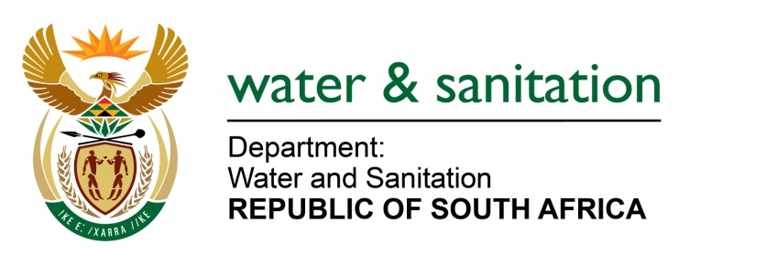

NATIONAL ASSEMBLY

FOR WRITTEN REPLY

QUESTION NO 1122

DATE OF PUBLICATION IN INTERNAL QUESTION PAPER: 31 MARCH 2023
(INTERNAL QUESTION PAPER NO. 12)

1122. Mr P Mey (FF Plus) to ask the Minister of Water and Sanitation:
(1) Whether his department has been informed that the residents of the Heidelberg and Ratanda areas in the Lesedi Local Municipality in Gauteng, have been without an adequate water supply for several weeks due to Rand Water’s inability to provide water to the specified communities; if not, why not; if so, what measures are being taken by his department to intervene in the specified matter, including the possibility of exempting the relevant water pump stations from electricity load shedding;
(2) whether he will make a statement on the matter? NW1261E
---00O00---
MINISTER OF WATER AND SANITATION
- The Department has been informed of the water supply challenges in Heidelberg and Ratanda areas. The City of Ekurhuleni (CoE) supplies electricity to the pumpstation which is operated by the Rand Water.). Rand Water and CoE are in discussion regarding efficient and sustainable electricity supply to this infrastructure. The options being explored include:
- Exemption of this water supply infrastructure from load shedding by the COE.
- Rand Water, with support from CoE, applying to Eskom for direct supply of electricity and thereafter be exempted from loadshedding as a critical facility.
- A statement will be made once an agreement has been concluded.

---00O00---

