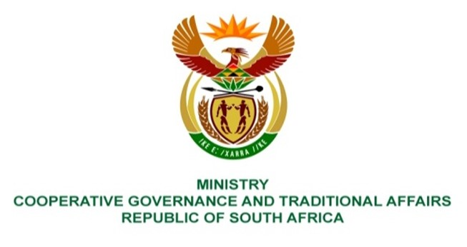

NATIONAL ASSEMBLY
QUESTION FOR WRITTEN REPLY

QUESTION NUMBER 1121
DATE OF PUBLICATION: 31 MARCH 2023

1121. Mr IM Groenewald (FF Plus) to ask the Minister of Cooperative Governance and Traditional Affairs:
- Whether the District Development Model (DDM) has delivered any quantifiable, successful outcomes at municipalities in terms of (a) financial management, (b) the maintenance and/or upgrading of infrastructure and (c) sustainable service delivery since its inception and announcement by the President of the Republic, Mr M C Ramaphosa in 2019; if not, why not, in each case; if so, (i) at which municipalities and (ii) in terms of which of the specified performance areas;
- what total amount was (a) allocated to and (b) spent on the DDM since 1 April 2019? NW1260E

REPLY:
- The DDM is currently in its institutionalization phase (April 2021 – March 2025) as outlined in the Cabinet approved DDM implementation framework. A key milestone under this phase is the development and implementation of well defined intergovernmental long term One Plans that outlines key DDM performance areas relating to planned intergovernmental local government stabilisation initiatives and short term service delivery improvement actions or interventions to be undertaken by all of government. To date 46 revised and updated intergovernmental One Plans have been developed for the respective districts and metro spaces following a intergovernmental One Plan quality assurance process that the department convened in 2022. The department together with its partners are currently finalizing a DDM information management system that will track and record the implementation of DDM initiatives and actions as outlined in One Plans starting in the 2023/24 financial year.
- The department has up until 31 March 2023 and through its partnership agreement with the Development Bank of Southern Africa (DBSA) spent a total amount of R103 431 703.59 million on various DDM institutionalization and implementation programs and projects in the three DDM pilot sites that also informed national DDM institutionalization and implementation initiatives. It should be reiterated that the institutionalization and implementation of the DDM approach requires all three spheres of government to re-align their strategic objectives and operational models with that of the DDM within their planning, budget, fiscal, and implementation frameworks. The DDM therefore does not require dedicated financial resources.
End.

