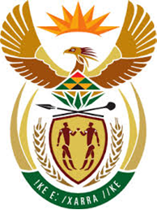

DEPARTMENT: PUBLIC ENTERPRISES
REPUBLIC OF SOUTH AFRICA

NATIONAL ASSEMBLY
QUESTION FOR A WRITTEN REPLY
QUESTION NO: 1117

QUESTION:
1117. Mr R A Lees (DA) to ask the Minister of Public Enterprises:
With regard to the presentation by the SA Airways business rescue practitioners on 25 March 2021 to the Standing Committee on Public Accounts, (a) what are the parliamentary and/or other processes that need to be resolved and/or followed before the R2,7 billion, earmarked for recapitalisation of the SA Airway's subsidiaries, will be paid out and (b) will these funds be paid to SAA or directly to the SAA subsidiaries? NW1304E

REPLY:
- The bill has been enacted into law. National Treasury through the Minister of Finance may provide more details on the special appropriation process should that be required.
- The funds will be paid to SAA as the shareholder and then transferred to the subsidiaries namely Mango, SAAT and Airchefs.

