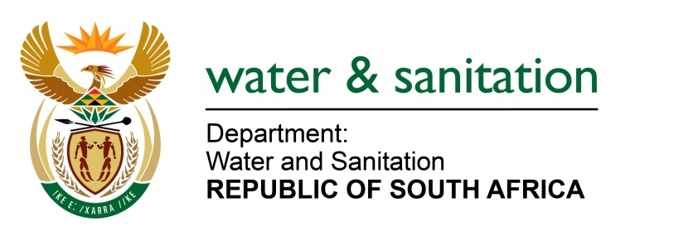

MINISTER OF WATER AND SANITATION

FOR WRITTEN REPLY

QUESTION NO 1116

DATE OF PUBLICATION IN INTERNAL QUESTION PAPER: 25 MARCH 2022
(INTERNAL QUESTION PAPER NO. 12)

1116. Mr L J Basson (DA) to ask the Minister of Water and Sanitation:

(1) Whether his department has any operational plans in place to resolve the infestation of the Hartbeespoort Dam by the water hyacinth plant; if not, why not; if so, what are the relevant details;

(2) what is the time frame for (a) cleaning and (b) prevention of the water hyacinth;

(3) whether any monitoring mechanisms are in place to monitor the incidence of invasive species at the specified dam; if not, why not; if so, what are the relevant details;

(4) what is the mandate of his department in terms of keeping dams and waterways clean and devoid of invasive species?

NW1368
---00O00---
MINISTER OF WATER AND SANITATION

- The North West Province Department of Economic Development, Environment Conservation and Tourism (DEDECT) and DWS are working together to implement the key components of the Hartbeespoort Dam Integrated Biological Remediation Programme Plan. The Hartbeespoort Dam Action Plan comprising of interventions to address among others, the water hyacinth infestation in the dam. These activities are coordinated through the Hartbeespoort Dam Coordinating Committee (HDCC). Some of the interventions being implemented to control the infestation of the dam are:

- My department has engaged the services of the Department of Forestry, Fisheries and Environment (DFFE) as the Implementing Agent for the project which is being implemented though the Working for Water Programme.

- The DFFE has deployed six (6) teams on the dam that are manually removing the water hyacinth plants.

- The DFFE is also implementing a biocontrol programme on the dam with the assistance of the Rhodes University’s Centre for Biological Control. The Centre for Biological Control (CBC) provides assistance by establishing various biocontrol mass rearing stations around the dam and constantly supplying the biocontrol agents. The biocontrol agents that have been released on the dam, the notable of which is the leaf hopper (Megamellus scutellaris), have been able to reduce the water hyacinth biomass on the dam exponentially. The rapid and significant reduction of water hyacinth has now been proven in two consecutive years.

The HDCC is considering mobilising the fish removal programme on the dam to comply to the AIS regulations promulgated in 2014, as well as section 24 of NEMA and section 70 (1)(a) and section 76 of NEM:BA. The exotic Chinese Carp and invasive Catfish (bottom feeding species), that have become dominant and invasive in the Hartbeespoort dam, need to be reduced and managed to support the indigenous algae eating Tilapia species.

The department will continue implementing the Working for Water Programme over the next 24 months, and thereafter re-assess whether it will still be necessary to continue with the manual removal of the water hyacinth. The biocontrol programme, which has resulted in a significant decrease in water hyacinth for two years in a row, will be continued as a sustainable control method.

- Additional to the visual recording and monitoring being done by the Working for Water under DFFE and DWS personnel, weekly satellite images are evaluated and interpreted to track the growth patterns. The system used is Sentinel 2A.

- The DWS is the national custodian for water in South Africa, including the water resource management in the dams. As the owner of the infrastructure, DWS is also legally responsible to control invasive species in the water and on state land. In terms of this responsibility, DWS signed a memorandum of understanding with DFFE to address these liabilities collectively.

---00O00---

