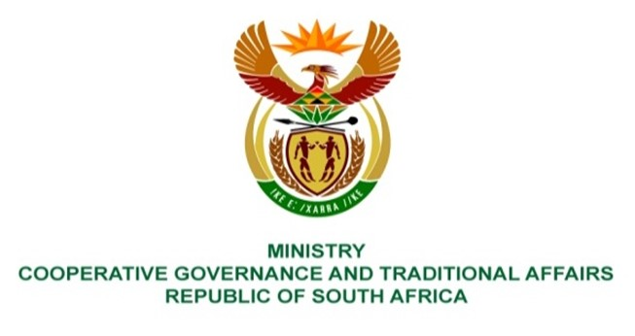

NATIONAL ASSEMBLY
QUESTIONS FOR WRITTEN REPLY
QUESTION NUMBER 1115

QUESTION:
1115. Ms H S Winkler (DA) to ask the Minister of Cooperative Governance and Traditional Affairs:
Whether her department will consider the deployment of personnel and/or other resources of the Municipal Infrastructure Support Agency (MISA) to prevent the further deterioration of service infrastructure in the Msunduzi Local Municipality in KwaZulu-Natal following months of prolonged and repeated water and electricity outages suffered by residents; if not, what other steps will the Government take in terms of section 154(1) of the Constitution of the Republic of South Africa, 1996, to prevent the further deterioration of service infrastructure in Msunduzi; if so, (a) by what date will such support be given and (b) what is the (i) nature and (ii) extent of the support? NW1367E

RESPONSE
The Department of Cooperative Governance (DCOG), through the Municipal Infrastructure Support agent (MISA) is already supporting Msunduzi Local Municipality (MLM) through the deployment of professionally registered technical professionals, a Civil Engineering young graduate, as well as a Town Planning young graduate in accordance with the District Development Model (DDM), to ensure that internal capacity is created with time for optimal delivery of basic services infrastructure.

The MLM is also a beneficiary of two Presidential Economic Stimulus (PES) programmes that MISA is implementing viz the Labour-Intensive Construction (LIC) and the Innovative Solid Waste Management (ISWM). The LIC programme aims to instutionalise LIC methodology and training of municipal officials in an effort maximise creation of work opportunities during project implementation as well as operation and maintenance. The involvement of the local community in infrastructure development contributes, among other things, towards asset ownership, less vandalism and improvement in service reliability. The ISWM programme includes the following activities:

  - Waste Collection & transportation by appointed Small, Medium and Micro Enterprises (SMMEs):
  - Clearing and cleaning of illegal dumping sites:
  - Recycling and separation of waste at source:
  - Ward specific clean up campaigns:
  - 1000 participants working under the ISWM programme.

The above support to MLM is in terms of section 154 (1) of the Constitution of the Republic of South Africa, 1996 which provides that “the national government and provincial governments, by legislative and other measures, must support and strengthen the capacity of municipalities to manage their own affairs, to exercise their powers and to perform their functions.”

According to MLM, there is further support provided by government and public institutions. The KwaZulu Natal (KZN) COGTA support includes the deployment of several technical experts for infrastructure delivery, financial management, disaster management and for the revision of the Local Economic Development (LED) Plan. Eskom entered into a partnership agreement with MLM whereby Eskom committed to provide project management and training support to MLM. Umngeni Water also entered into an agreement with MLM regarding the Darvill sewer outfall pipe that requires urgent major repairs. The planning of the works is at an advanced stage.

Government has also taken other steps to support local government including MLM. DCOG together with MISA, all provincial departments responsible for local government and provincial treasury departments, under the leadership of the Minister of COGTA, prepared the State of Local Government (SOLG) report that was tabled and considered by Cabinet in June 2021. Cabinet’s resolutions on the SOLG report included that COGTA and National Treasury should lead the process of the development of the Municipal Support and Intervention Plans (MSIPs) in collaboration with sector departments, the South African Local Government Association (SALGA), provinces and municipalities. MSIPs, including that of MLM, have since been prepared.

The implementation of MSIPs will be done in accordance with the DDM approach. The DDM approach includes the whole of government and all other interested and affected parties to plan, implement and monitor developmental work in all 52 district spaces that cover the whole country.

MLM is allocated infrastructure grant funding annually by national government that includes the Municipal Infrastructure Grant (MIG) and the Water Services Infrastructure Grant (WSIG) to fund the implementation of basic services.

