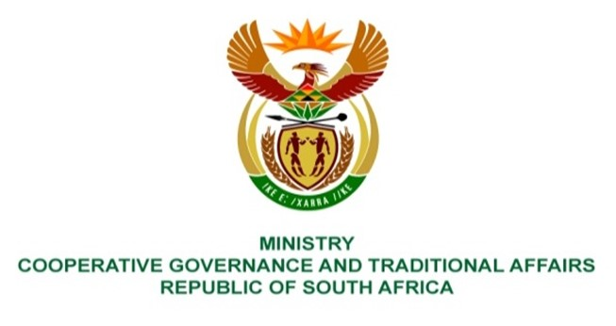

NATIONAL ASSEMBLY
QUESTIONS FOR WRITTEN REPLY
QUESTION NUMBER: 1114

QUESTION:

1114. Ms H S Winkler (DA) to ask the Minister of Cooperative Governance and Traditional Affairs:
Whether she has been informed that the Msunduzi Business Forum has conducted an assessment of the service infrastructure of the Msunduzi Local Municipality in KwaZulu-Natal following months of prolonged and repeated water and electricity outages suffered by the community, and that the Forum has offered to share the information with Government to assist the province and the specified municipality in the fulfilment of their executive obligations; if not, will she meet with the Forum and other stakeholders in the municipality to consider the information; if so, what steps are being taken by the (a) national and (b) provincial government to act on the information?

REPLY

I have not been informed about the said assessment by the Msunduzi Business Forum (MBF).

According to Msunduzi Local Municipality (MLM), MLM is also not aware of any assessment or study that has been conducted by the MBF, but is aware of the following assessments done:

- The Department of Cooperative Governance (DCOG) together with the Municipal Infrastructure Support Agent (MISA), all provincial departments responsible for local government and provincial treasury departments, under the leadership of the Minister of COGTA, prepared the State of Local Government (SOLG) report that was tabled and considered by Cabinet in June 2021. Cabinet’s resolutions on the SOLG report included that COGTA and National Treasury should lead the process of the development of the Municipal Support and Intervention Plans (MSIPs) in collaboration with sector departments, the South African Local Government Association (SALGA), provinces and municipalities. MSIPs, including that of MLM, have since been prepared.
- The Development Bank of Southern Africa (DBSA) Asset Management Care assessment that is currently underway.
- The KwaZulu Natal (KZN) COGTA assessment on electricity outages that was done in December 2021.

Government has adopted the District Development Model (DDM) to plan, implement and monitor developmental work in all 52 district spaces that cover the whole country. The DDM approach includes whole of government and all other interested and affected parties, including community forums.

To that end, the implementation of MSIPs will be done in accordance with the DDM approach.

Furthermore, DCOG, through MISA supports MLM through the deployment of technical professionals, in accordance with the District Development Model (DDM), to ensure that internal capacity is created with time for optimal delivery of basic services infrastructure. This is in terms of section 154(1) of the Constitution of the Republic of South Africa, 1996.

