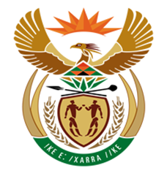

NATIONAL ASSEMBLY
QUESTION FOR WRITTEN REPLY
QUESTION NUMBER: 1113 [NW1253E]
DATE OF PUBLICATION: 15 MAY 2017

1113. Mr D J Maynier (DA) to ask the Minister of Finance:
(1) Whether he has ever met with certain persons (names furnished); if not, in each case, why not; if so, what are the relevant details in each case;
(2) whether he has ever received any (a) gifts or (b) payments from certain persons (names furnished); if not, in each case, why not; if so, what are the relevant details in each case;
(3) will he make a statement on the matter?
NW1253E
REPLY:

- I have never had formal meetings with them.

- No, I have declared all gifts I have received since my appointment as Member of Parliament and Member of the National Executive.

- No statement will be made.

