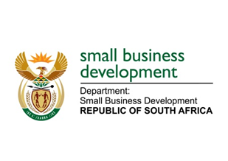

NATIONAL ASSEMBLY

QUESTION FOR WRITTEN REPLY

“1112. Mr T E Mulaudzi (EFF) to ask the Minister of Small Business Development:

What (a) number of consulting firms or companies are currently contracted by (i) her department and (ii) the entities reporting to her and (b)(i) is the name of each consultant, (ii) are the relevant details of the service provided in each case and (iii) is the (aa) start date, (bb) time period, (cc) monetary value in Rands of each contract and (dd) name and position of each individual who signed off on each contract?”
NW1204E

REPLY:

The details of consulting firms or companies that are currently contracted by the Department of Small Business Development (DSBD), and its entities (the Small Enterprise Development Agency [SEDA] and the Small Enterprise Finance Agency [SEFA]) are attached as Annexure A.

