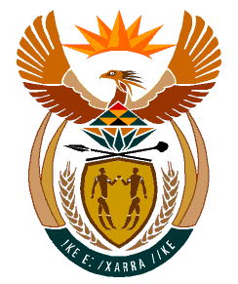

MINISTRY:
HUMAN SETTLEMENTS, WATER AND SANITATION
REPUBLIC OF SOUTH AFRICA

NATIONAL ASSEMBLY

QUESTION FOR WRITTEN REPLY

QUESTION NO.: 1109

DATE OF PUBLICATION: 11 OCTOBER 2019

Mrs G Opperman (DA) to ask the Minister of Human Settlements, Water and Sanitation:
By what date does her department envisage that the White Paper on Human Settlements will be finalised? NW2268E

REPLY:

During the 2014 – 2019 Medium Term Strategic Framework (MTSF) period, the Department of Human Settlements commenced with the process of developing a White Paper on Human Settlements. However, this process was paused due to the fact that the process of developing a White Paper started at the same time as the process of evaluating policy programmes. The evaluation piece was done by the Department of Human Settlements in partnership with the Presidency, driven by the Cabinet approved evaluation program.

The Department is in the process of developing a Macro Policy Framework for Human Settlements. Extensive progress has been made in this regard, including a series of dialogues with sector stakeholders who are currently grappling with the causal pathways on the issue of Housing and Human Settlements – allowing for a Human Settlements legislative reform by the end of 2020. It must be emphasized that, the Comprehensive Plan for the creation of the Sustainable Human Settlements commonly known as the (Breaking New Ground (BNG) remains valid and in place as the legal framework on Human Settlements.

