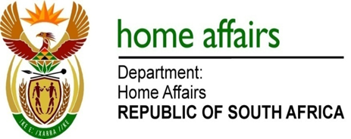

NATIONAL ASSEMBLY

QUESTION FOR WRITTEN REPLY

QUESTION NO. 1105

DATE OF PUBLICATION: Monday, 15 May 2017

INTERNAL QUESTION PAPER 16 OF 2017

1105. Mr C MacKenzie (DA) to ask the Minister of Home Affairs:

What (a) amount was spent by her department on e-government services in the 2016-17 financial year and (b) is the projected expenditure for the 2017-18 financial year? NW1245E
REPLY:

E-government services are the services that Government render to the public online through the internet. In this regard, the Department of Home Affairs has developed an eHome Affairs Portal which enables citizens to apply for smart ID Cards and Passports online. The Portal was launched on 07 April 2016.
- FY2016/17 Expenditure
- Development of the eHome Affairs Portal – R6 960 447.19
- Post Release Enhancements of eHome Affairs – R2 846 908.79
- Support and Maintenance of the eHome Affairs system – R887 494.97

It is to be noted that the development of the Portal includes upgrade to Live Capture system and revenue systems to enable EFT payments and integration to various core systems.

- FY2017/18 Budget allocation for eHome Affairs Portal
- Planned enhancement of eHome Affairs Portal – R2 500 000.00
- Maintenance and Support of the System – R1 000 000.00
- Hosting and Internet Connectivity for eHome Affairs (including hardware procurement) – R10 000 000.00

