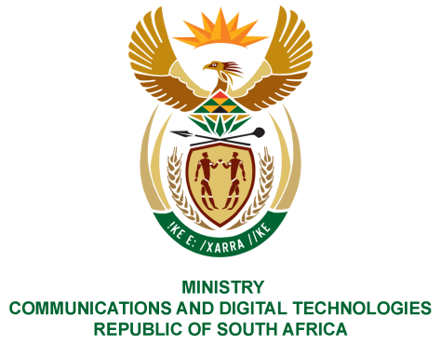
PARLIAMENT OF THE REPUBLIC OF SOUTH AFRICA
NATIONAL ASSEMBLY
WRITTEN REPLY

QUESTION NO: 1099
DATE OF PUBLICATION: 7 MAY 2021
QUESTION PAPER NO: 12
Mr C MacKenzie (DA) to ask the Minister of Communications and Digital Technologies:
Whether, with reference to her reply to question 538 on 16 March 2021 and the appointment of a certain company (name furnished) as an authorised representative of the SA Post Office (SAPO) on 5 February 2020, any services, technology and/or products have been supplied by the specified company to the SAPO; if not, what is the position in this regard; if so, (a) what is the nature of the services rendered, technology and/or products supplied, (b) what is the monetary value of the services, technology and/or products and (c) was any request for proposal and/or request for quotation issued? NW1286E
REPLY:

I have been advised by the SAPO as follows:
The contractual matters involving the parties, including possible requests for proposals and/or requests for quotations are currently under review as part of an internal disciplinary process. SAPO is therefore unable to provide details until such time that this process has been finalised.

MS. STELLA NDABENI-ABRAHAMS, MP
MINISTER OF COMMUNICATIONS AND DIGITAL TECHNOLOGIES

