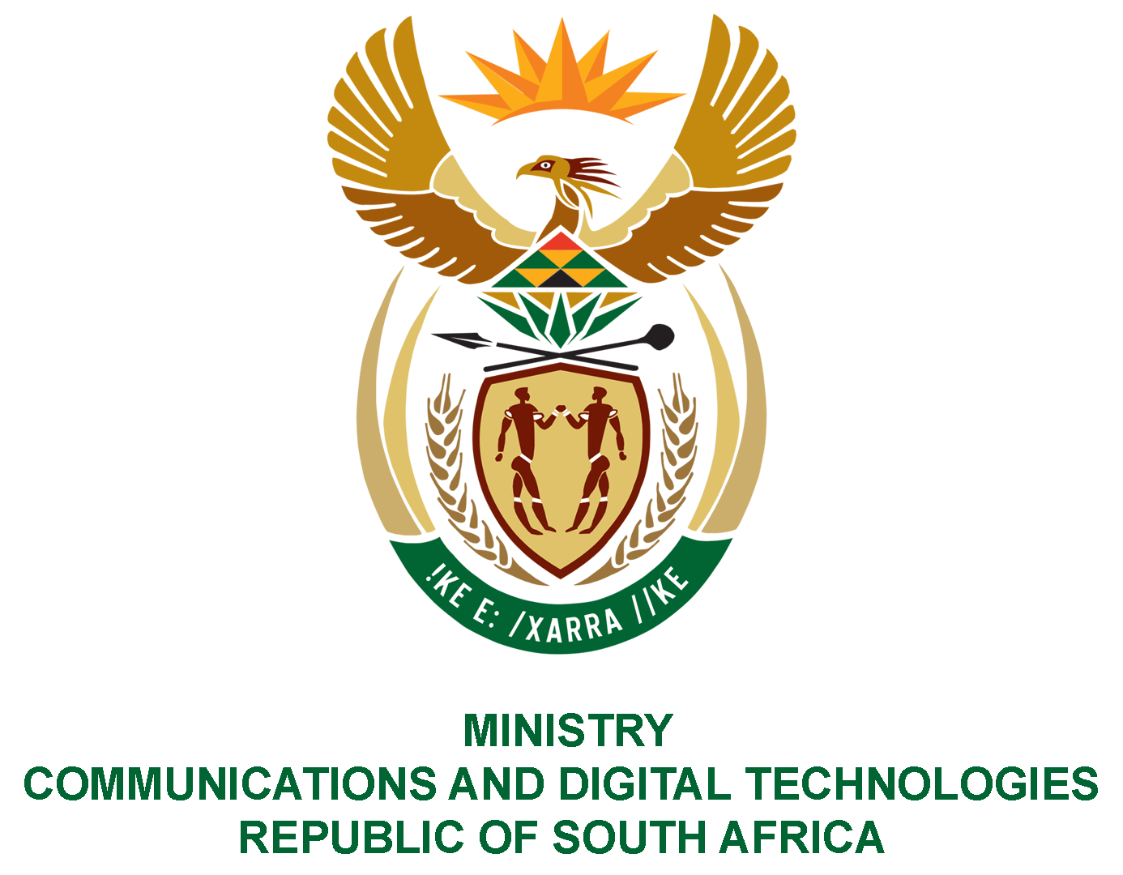

PARLIAMENT OF THE REPUBLIC OF SOUTH AFRICA

NATIONAL ASSEMBLY

WRITTEN REPLY

QUESTION: 1092

DATE OF PUBLICATION: 25 MARCH 2022
QUESTION PAPER NO: 12
Ms Z Majozi (IFP) to ask the Minister of Communications and Digital Technologies:
Noting her media statement on 18 March 2022 relating to the auction of the high-demand frequency communication spectrum, wherein it was mentioned that the auction raised R6 billion above the initially anticipated amount, (a) what total amount was raised by the auction, (b) how will the specified amount be utilised, particularly in light of the R6 billion that was not anticipated and probably not budgeted for and (c) what is the detailed breakdown of how the funds will be used?
NW1342E

REPLY

I have been advised by the Department as follows:
- The total raised by the high-demand radio frequency spectrum auction is
R14 477 889 512.60.
- The revenue collected from the auction will go to the national fiscus.
- Any details on the spending of the amount can be directed to the Minister of Finance.

