

**MINISTRY**

**STATE SECURITY**

**REPUBLIC OF SOUTH AFRICA**

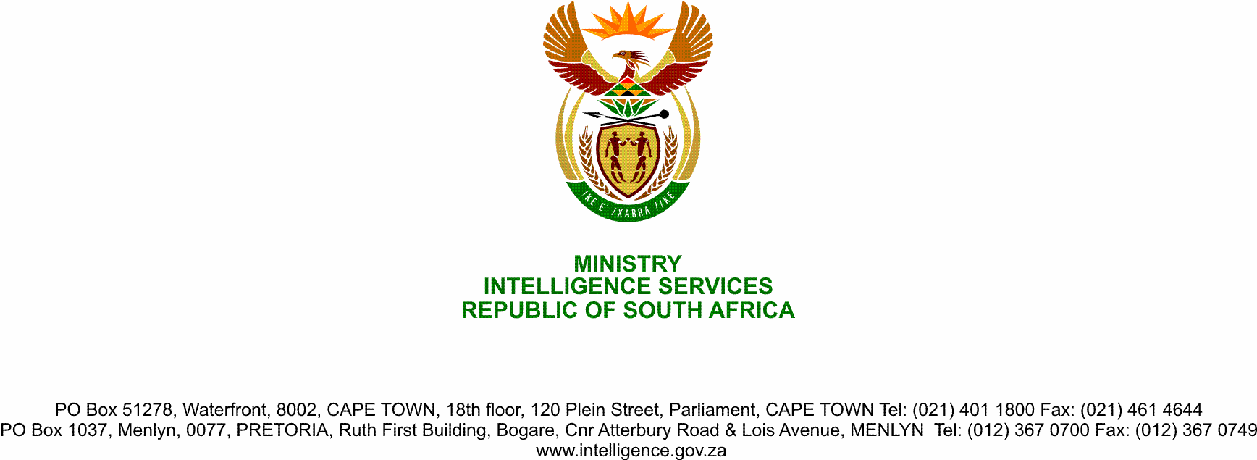

**NATIONAL ASSEMBLY**

**QUESTION FOR WRITTEN REPLY**

**QUESTION NO.: 1092.**

**Ms D Kohler (DA) to ask the Minister of State Security:**

1. What (a) number of persons are currently employed in an (i) administrative and (ii) operational capacity in the State Security Agenc’s (aa) domestic and (bb) foreign intelligence Divisions, (b) number of the specified persons have criminal records in each case and (c) are the relevant details of the (i) offence(s) each person was convicted of and (ii) date on which each conviction was made;
2. Why are the persons with criminal records employed in each of the specified Intelligence Divisions?

NW1388E

**REPLY**

**1 (a)**

**1. (aa)** (i)Operational Capacity is: 1501 and

(ii) Administrative Capacity is: 147

**1. (bb)** (i) Operational Capacity is: 291 and

(ii) Administrative Capacity is: 22

**1. (b)** None

**1. (c)** (i) & (ii) Not applicable given 1(b).

**2.** Not applicable given 1(b).