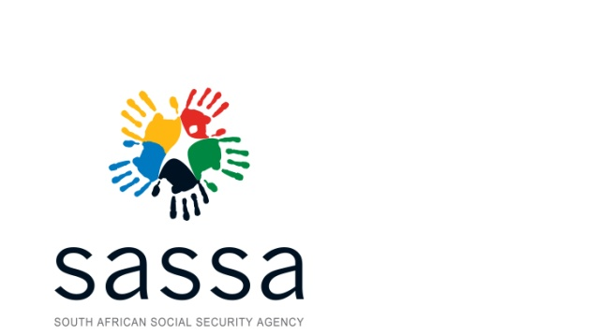
9

SUBMISSION

To: | Ms L Zulu, MP  Minister of Social Development
From: | Mr A Mahlangu  Acting Chief Executive Officer (SASSA)
Date: | 16 October 2019
Subject: | Request for approval of written reply to Parliamentary Question 1091 of 2019
Enquiries: | Ms Lesego Lekalake ext 2115

Purpose:
To provide the Minister with the response to written Parliamentary question 1091 of 2019 asked by Ms B S Masango (DA)

Recommendation:
It is recommended that:
- The Minister considers and approves the reply to Parliamentary Question 1091 of 2019.

---------------------------------
Mr Abraham Mahlangu
Acting Chief Executive Officer: SASSA
Date:

APPROVAL OF WRITTEN REPLY TO PARLIAMENTARY QUESTION 1091: MS B S MASANGO (DA)
1091. Ms B S Masango (DA) to ask the Minister of Social Development:
(1) What is the current status of all court cases that her department brought against Cash Paymaster Services (CPS);
(2) (a) how far is the process of paying back R316 million by CPS to the SA Social Security Agency and (b) what steps will she take against officials who paid CPS contrary to documentation confirming that all the money that was due to CPS had been paid? NW2250E
REPLY:

(1) SASSA has instituted legal proceedings against CPS for the recovery of R 74 million payments made to CPS. In the months of February and March 2018 SASSA paid 2 160 678 and 2 388 403 beneficiaries respectively, directly into their bank accounts without using the services of CPS.

CPS has, upon receipt of the summons claiming payment of R 74 million, filed a notice of exception to SASSA`s particulars of claim, demanding that SASSA provides more facts (such as contractual basis and principles upon which the claim is based). SASSA amended its particulars of claim (by incorporating other terms of the contract [contract for the payment of social grant services concluded with CPS during 2012]) and filed the notice to amend on 27 September 2019. CPS has filed a notice of objection to SASSA`s amendment on 11 October 2019. This matter is still pending arguments in Court.

(2)(a) SASSA has sent a letter to CPS on 10 October 2019 demanding that CPS implements paragraph 36.2 (ordering CPS to pay R 316 million with interests) of the High Court order since CPS`s appeal to the Supreme Court of Appeal (SCA) has been dismissed. CPS indicated in its letter dated 14 October 2019 that it is preparing to appeal to the Constitutional Court (CC) against the SCA judgment. SASSA will await the outcome of the intended appeal and if the SCA judgment is not overturned, SASSA will enforce paragraph 36.2 of the High Court judgment.

(2)(b) The official who authorised the R 316 million transaction (afforded CPS the right to claim R 316 million) is no longer in the employ of SASSA and it is only recently in September 2019, that the Court made a ruling on the R316m payment which was made in 2014.

Supported/Not supported

-----------------------------------
Mr M Toni
Acting Director-General: Dept. of Social Development
Date:

Supported/Not supported

-----------------------------------
Ms H Bogopane-Zulu
Deputy Minister: Dept. of Social Development
Date:

Approved/Not approved

-----------------------------------
Ms L Zulu, MP
Minister: Department of Social Development
Date:

