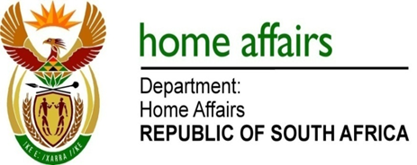

NATIONAL ASSEMBLY

QUESTION FOR WRITTEN REPLY

QUESTION NO. 1090

DATE OF PUBLICATION: Monday, 15 May 2017

INTERNAL QUESTION PAPER 16 OF 2017

1090. Ms D Carter (Cope) to ask the Minister of Home Affairs:

(1) What is the total number of designated marriage officers that (a) her department currently has and (b) have been exempted from solemnising a civil union between persons of the same sex;
(2) whether, given our constitutional order, it is her position that a marriage officer of her department may be exempted from solemnising a civil union between persons of the same sex; if not, would she introduce amending legislation to repeal section 6 of the Civil Union Act, Act 17 of 2006; if so, why? NW1229E
REPLY:

(1)(a) 1 130 designated marriage officers
(1)(b) 421 marriage officers are exempted to perform Civil Union Marriages whereby they objected on the grounds of conscience, religion or belief.

(2) This is not a Ministerial prerogative but a provision of the law in terms of section 6 of the Civil Union Act, 2006 (Act No. 17 of 2006) – A marriage officer, other than a marriage officer referred to in section 5, may in writing inform the Minister that he or she objects on the ground of conscience, religion and belief to solemnising a civil union between persons of the same sex, whereupon that marriage officer shall not be compelled to solemnise such civil union. The Act is clear in that marriage officers will not be compelled to solemnise such civil unions.

