NATIONAL ASSEMBLY
36/1/4/1(201900004)

FOR WRITTEN REPLY QUESTION 109
DATE OF PUBLICATION IN INTERNAL QUESTION PAPER: 7 FEBRUARY 2019 (INTERNAL QUESTION PAPER NO 1-2019)

109. Mrs A M Dreyer (DA) to ask the Minister of Police:

With regard to case number 553/12/2018 reported at the Boksburg North Police Station, (a) who is the investigating officer and (b) what progress has been made in the case?

REPLY:
NW114E

- The particulars of the investigating officer cannot be divulged, to ensure that the case is investigated without fear or favour.

- The suspect in this case, resigned from the company. The complainant was contacted and the suspect's address was obtained. The address was visited, but the suspect could not be found. All possible leads to trace the suspect, are being followed. The case is, therefore, still under investigation.

Reply to question 109 recommended/

TI
OLE (SOEG)
GENERAL ER: TH AFRICAN POLICE SERVICE

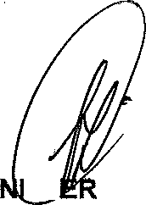
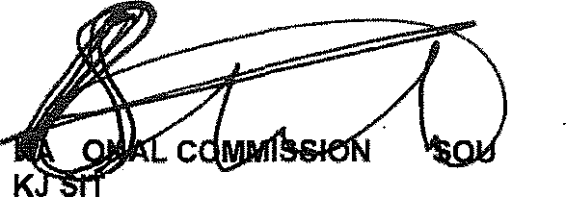
Reply to question 109 approved/ o e

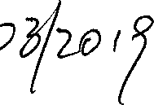MI SI OF POLICE BH CELE, MP

Date:

