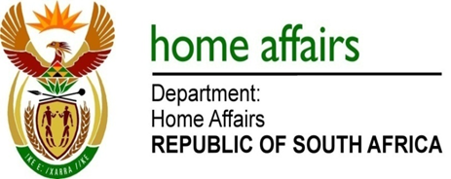

NATIONAL ASSEMBLY

QUESTION FOR WRITTEN REPLY

QUESTION NO. 1087

DATE OF PUBLICATION: FRIDAY, 20 APRIL 2018

INTERNAL QUESTION PAPER 12 OF 2018

1087. Mrs H O Mkhaliphi (EFF) to ask the Minister of Home Affairs:

What (a) number of consulting firms or companies are currently contracted by (i) his department and (ii) the entities reporting to him and (b)(i) is the name of each consultant, (ii) are the relevant details of the service provided in each case and (iii) is the (aa) start date, (bb) time period, (cc) monetary value in Rands of each contract and (dd) name and position of each individual who signed off on each contract? NW1179E
REPLY:

The department and entities responded as follows:

- Department of Home Affairs

(a) Three (3)
(b)(i) See schedule attached as Annexure A.
(b)(ii) – (iii) See schedule attached as Annexure A.

- Government Printing Works
(a) Fifteen (15)
(b)(i) See schedule attached as Annexure B.
(b)(ii) – (iii) See schedule attached as Annexure B.

- Electoral Commission
(i) Eighty (80)
(i) See schedule attached as Annexure C.
(b)(ii) – (iii) See schedule attached as Annexure C.

