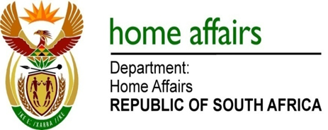

NATIONAL ASSEMBLY

QUESTION FOR WRITTEN REPLY

QUESTION NO. 1087

DATE OF PUBLICATION: Monday, 15 May 2017

INTERNAL QUESTION PAPER 16 OF 2017

1087. Ms H O Hlophe (EFF) to ask the Minister of Home Affairs:

Whether her department awarded any tender to companies associated with a certain person (details furnished), either as an employee or a director; if not what is the position in this regard; if so, (a) which tenders were awarded and (b) for what work? NW1226E
REPLY:

The Department of Home Affairs is not in a position to respond to the above question as the Department does not know which company / companies the person referred to is associated with or working for. The person referred to is and was not employed by the Department.

