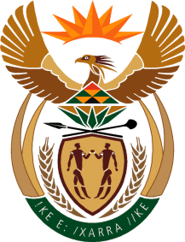

MINISTRY OF TOURISM

REPUBLIC OF SOUTH AFRICA

Private Bag X424, Pretoria, 0001, South Africa. Tel. (+27 12) 444 6780, Fax (+27 12) 444 7027

Private Bag X9154, Cape Town, 8000, South Africa. Tel. (+27 21) 469 5800, Fax: (+27 21) 465 3216

Ref: TM 2/1/1/10

NATIONAL ASSEMBLY:

QUESTION FOR WRITTEN REPLY:
Question Number: 1083
Date of Publication: 15 April 2016
NA IQP Number: 11
Date of reply: 10 May 2016

Ms P Ntobongwana (EFF) to ask the Minister of Tourism:
(a) Has any of his senior officials met with certain persons (names furnished) during the period 1 January 2009 up to 31 December 2015 and (b) has any of the entities reporting to him awarded any contracts to Sahara Holdings, Comair, Oakbay Investments, Islandsite Investments, Afripalm Horizons Stakes, The New Age Media, JIC Mining Services and Vusizwe Media in the specified period; if so, what (i) are the relevant details and (ii) is the amount of each specified contract? NW1215E

Reply
- No.

- No.

(i) Not applicable

(ii) Not applicable

