MINISTER OF HUMAN SETTLEMENTS: N MFEKETO DIRECTOR-GENERAL: MS TSHANGANA

NATIONAL ASSEMBLY QUESTION FOR WRITTEN REPLY QUESTION NUMBER: PQ 1079

DATE OF PUBLICATION: 26 MAY 2018

REPLY RECOMMENDED BY: MS TSHANGANA
DIRECTOR-GENERAL

NATIONAL ASSEMBLY QUESTION FOR WRITTEN REPLY QUESTION NUMBER: PQ 1079
DATE OF PUBLICATION: 26 IgAY 2018

1079. Ms NKF Hlonyana (EFF) to ask the Minister of Human Settlements:

(a) What are the reasons that the tender that was initially awarded by her department to a certain local company to build 1050 Reconstruction and Development Programme houses in Vogelfontein in the Free State was cancelled and awarded to a certain Chinese company ,(b) who authorised the cancellation,(c) on what basis was the contract cancelled ,(d) what was the value of the initial contract awarded to the local company,(e) what procedures were followed by her department in awarding the contract to the Chinese company and
(f) who authorised the awarding of the contract to the Chinese company?

REPLY:

- The Free State Department of Human Settlements has indicated that their Department has not appointed a Company, called Emendo Incorporated to build 1 050 RDP houses in Vogelfontein.
- N/A
- N/A
- N/A
- The Free State Department of Human Settlements indicated that they appointed the contractor through the Departmental Database that was established in terms of the prescripts of the Public Finance Management Act No.‹ 1 of 1999, and the project was approved for implementation by MEC in terms of the provisions of the Housing Act No. 107 of 1997 (section 7(3)(a).
  - The project was approved and allocated by the MEC for Human Settlements in Province in terms of section 7(3)(a) of the Housing Act of No 107 of 1997.

NATIONAL ASSEMBLY

QUESTION FOR WRITTEN REPLY

QUESTION NUMBER: PQ 1078
DATE OF PUBLICATION: 26 MAY 2018

TLATSI

DEPUTY DIRECTOR-GENERAL: CHIEF FINANCIAL OFFICER
DATE:

Recommended/id

N CHAINEE
DEPUTY DIRECTOR-GENERAL: CHIEF OPERATIONS OFFICER DATE: Q . 0 l / •
Recommended/n I recommended
HA GAN DIRECTOR-G DATE:

Approved/ ot approved

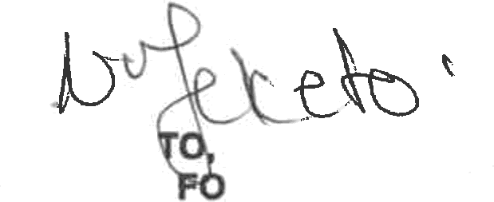
N MFEKE MP
MINISTER R HUMAN SETTLEMENTS

DATE:

