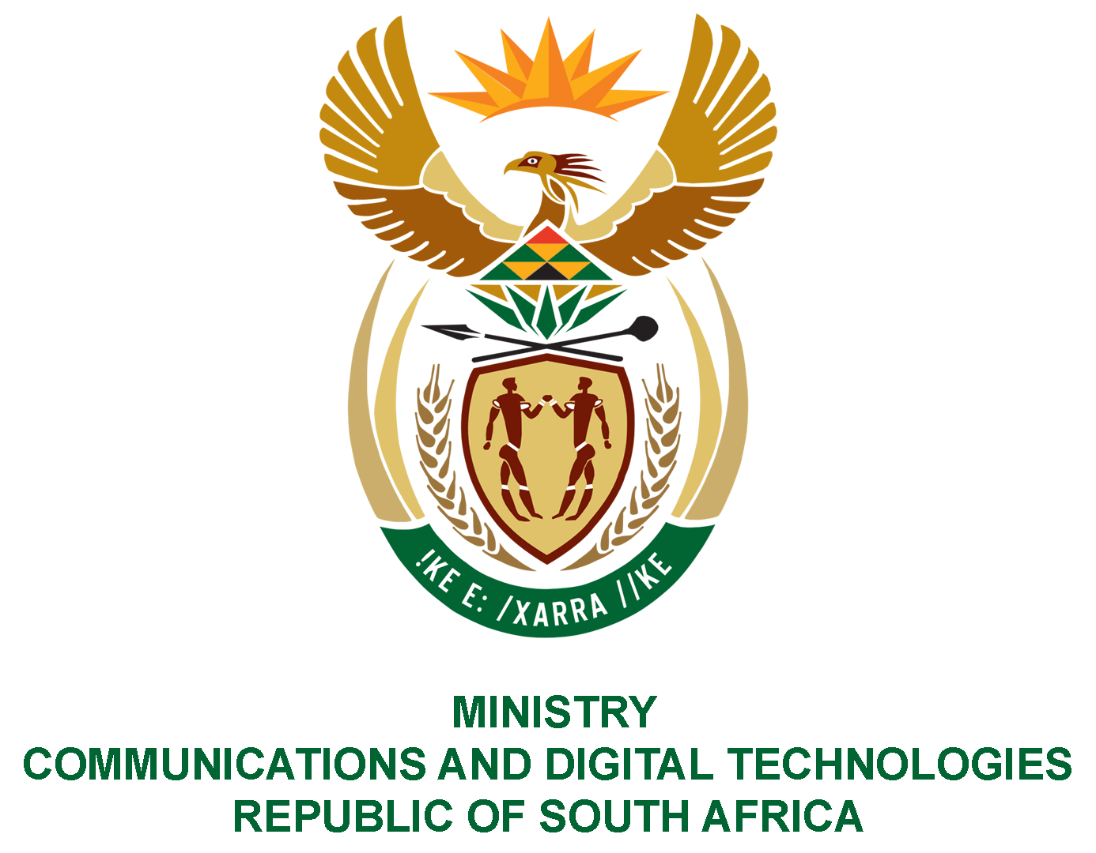

PARLIAMENT OF THE REPUBLIC OF SOUTH AFRICA

NATIONAL ASSEMBLY

WRITTEN REPLY

QUESTION: 1077

DATE OF PUBLICATION: 25 MARCH 2022
QUESTION PAPER NO: 12

Mr M S Malatsi (DA) to ask the Minister of Communications and Digital Technologies:

What amount does (a) Universal Service and Access Agency of South Africa and, (b) Film and Publication Board, owe the (i) Tshwane Metropolitan Municipality, (ii) Johannesburg Metropolitan Municipality and (iii) Ekurhuleni Metropolitan Municipality for (aa) water, (bb) rates and (cc) electricity as at 7 March 2022?
NW1324E

REPLY:

I have been advised by the SOEs as follows:

(a)- (b) USAASA and FPB have indicated that they do not owe any of the mentioned municipalities.

Authorised for submission by

MS. NONKQUBELA JORDAN-DYANI
DIRECTOR-GENERAL (ACTING)
DATE:

Recommended/not recommended

__________________________
HON. PHILLY MAPULANE, MP
DEPUTY MINISTER OF COMMUNICATIONS AND DIGITAL TECHNOLOGIES
DATE:

Approved/ not approved

________________________________
HON. KHUMBUDZO NTSHAVHENI, MP
MINISTER OF COMMUNICATIONS AND DIGITAL TECHNOLOGIES
DATE:

