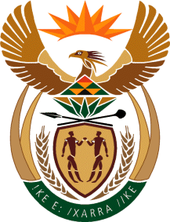

MINISTRY: COMMUNICATIONS
REPUBLIC OF SOUTH AFRICA
Private Bag X 745, Pretoria, 0001, Tel: +27 12 473 0164 Fax: +27 12 473 0585
Tshedimosetso House,1035 Francis Baard Street, Tshedimosetso House, Pretoria, 1000

NATIONAL ASSEMBLY
QUESTION FOR WRITTEN REPLY
QUESTION NUMBER: 1077
DATE OF PUBLICATION: APRIL 2016

Ms N W A Mazzone (DA) to ask the Minister of Communications:
Whether all the winners of the 15th Metro FM Awards held on 27 February 2016 have received their prize money; if not, (a) why not, (b) which of the winners have not received their prize money, (c) when will they receive their prize money and (d) in what format has/will the prize money be transferred? NW1180E

REPLY: MINISTER OF COMMUNICATIONS

All of the 15th Metro Awards have been paid, except Casper Nyovest (Best Hip Hop). The delay in payment of Casper Nyovest is as a result of the fact that the station is awaiting proof of banking details from the artist. Attempts to get the documents from him has been made to no avail. It should be noted that the Metro FM Awards takes place at no cost to the SABC as they are fully funded through sponsorships and partnerships. However, the SABC administers the funds thereof.

MR NN MUNZHELELE
DIRECTOR GENERAL [ACTING]
DEPARTMENT OF COMMUNICATIONS
DATE:

MS AF MUTHAMBI (MP)
MINISTER OF COMMUNICATIONS
DATE:

